FireBase

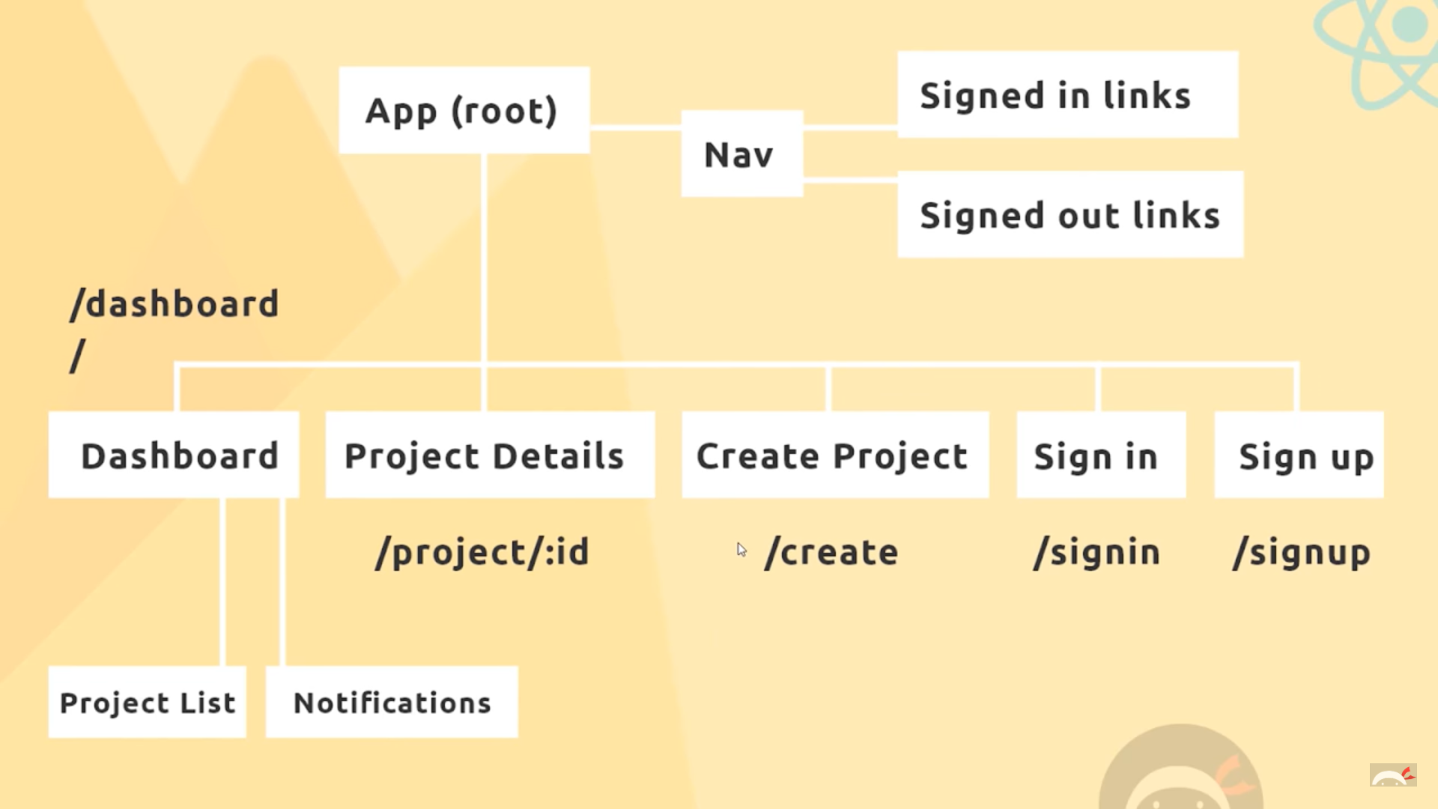

The Plan Of Action

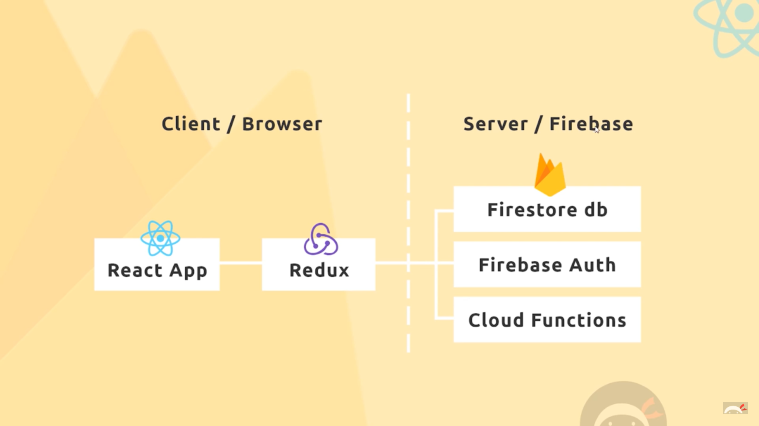

1. First make the NavBar component.
2. Then make the SignedInLinks using the NavLink as we need active class for this.
3. <li><NavLink to='./' className="btn btn-floating blue lighten-

1"><strong>YG</strong></NavLink></li>

The above css class is required for the blue circular container . Also **brand-logo** in the Link tag is an imp css class.

1. 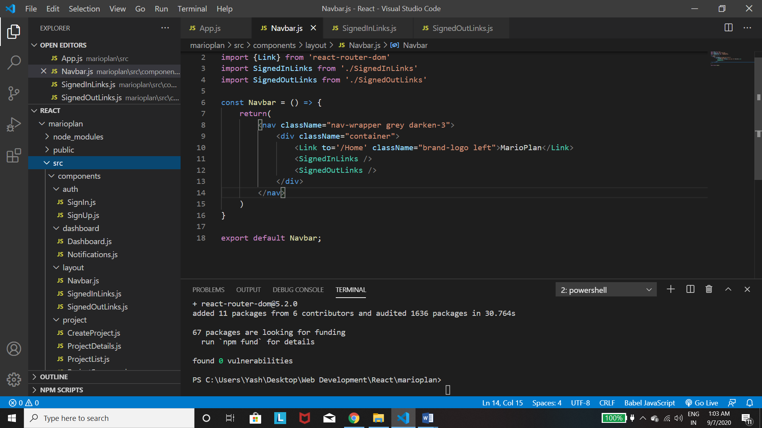

In this the *brand-logo* was really imp for giving the logo a proper shape

1. 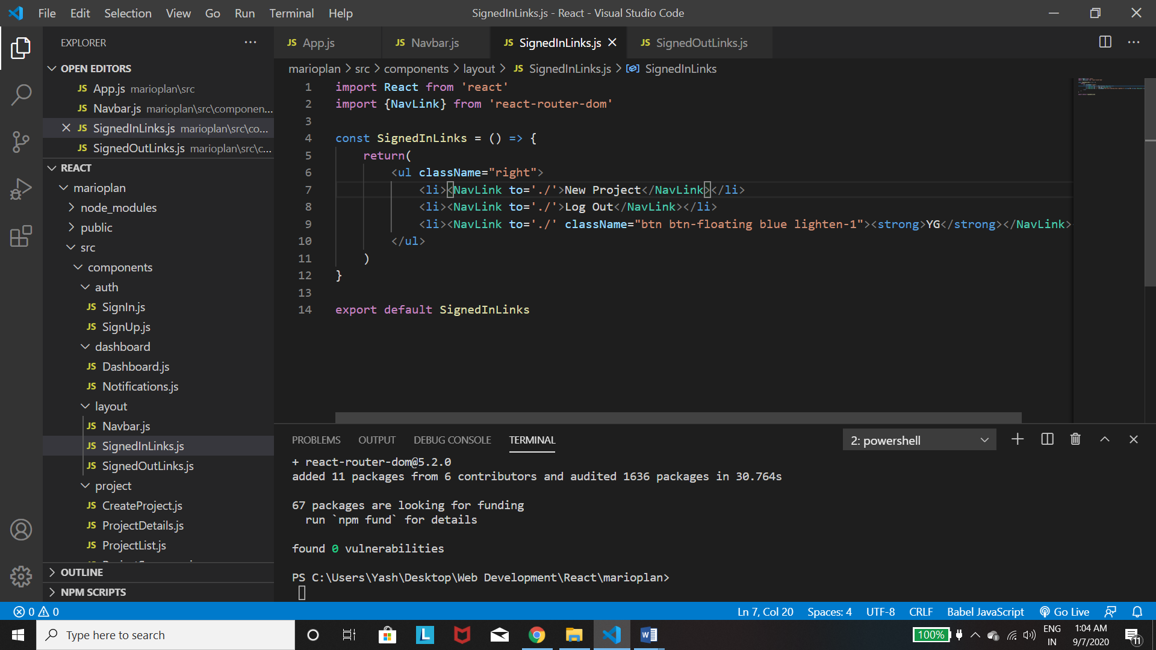

The third *Navlink* which helps in making a *circular name* is imp.

1. 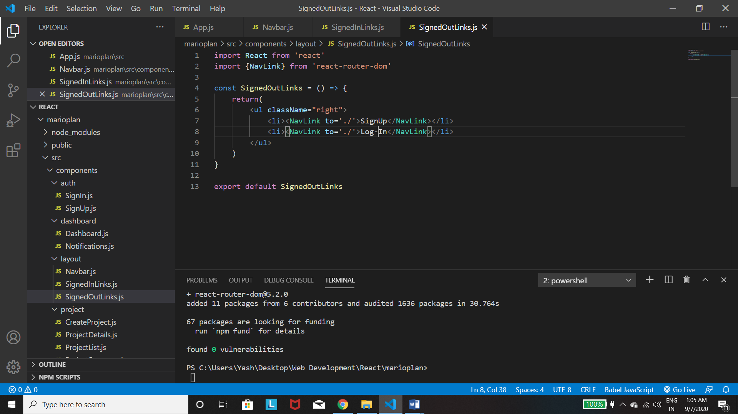

Not many new Stuffs.

1. 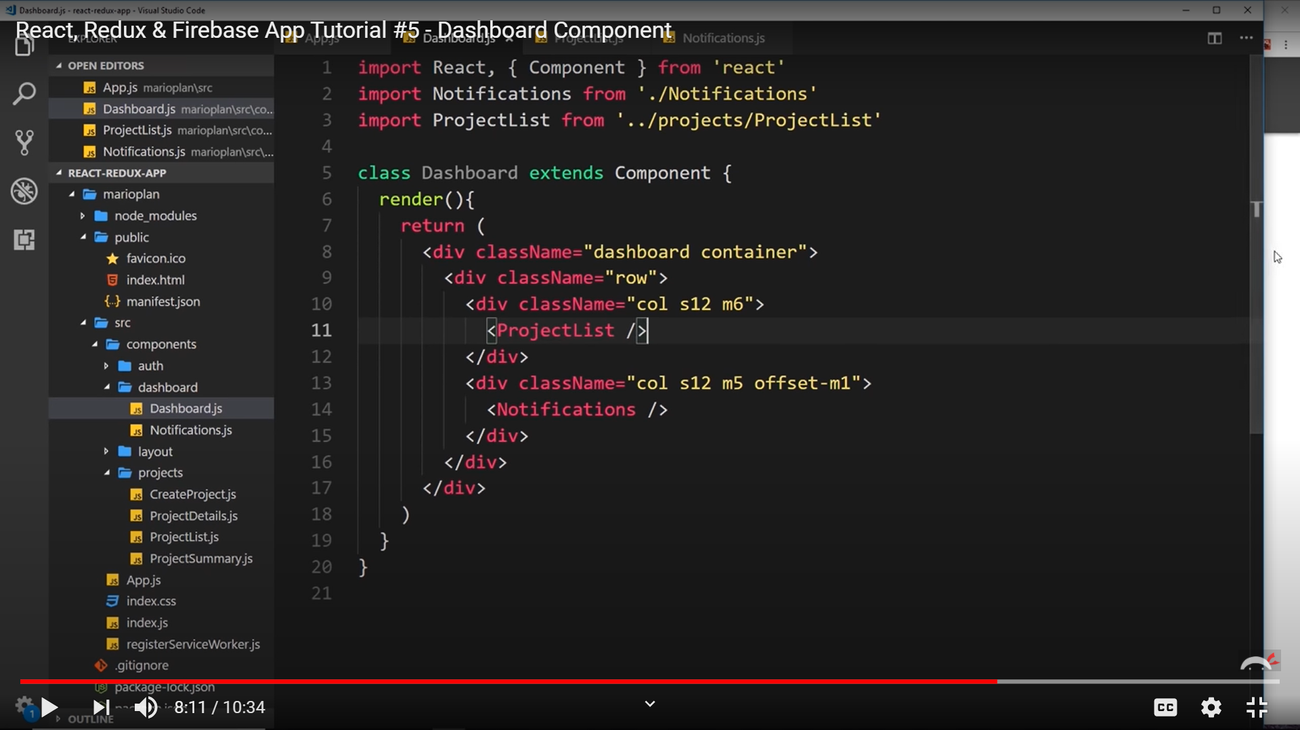

Here the first container is imp, then we have to divide the page into 2 parts using the row and col in the separate divs. The s12 and m6 signifies the number of parts in which we need to divide our page upto. The m5 in the last with the offset is responsible for leaving some gaps.

1. 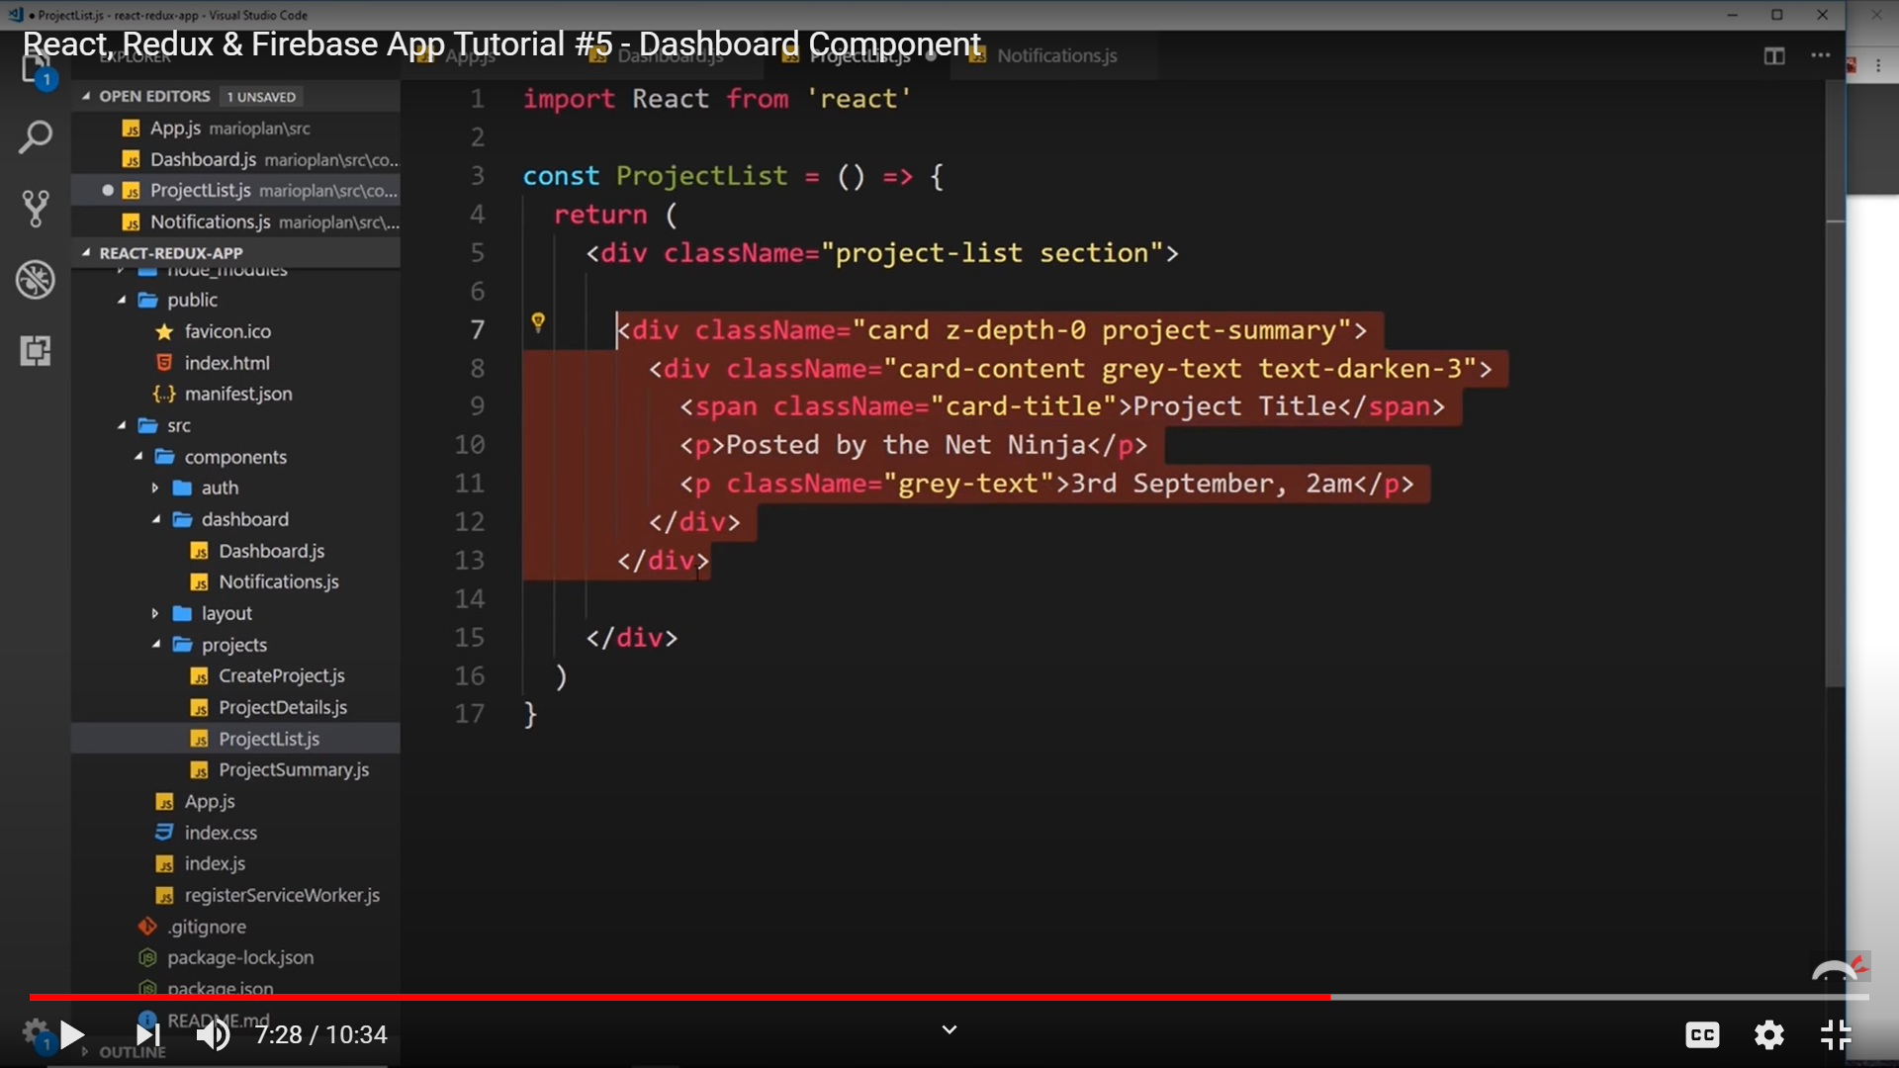

Here the *card* is responsible for making separate projects. The *z-depth-0* is used to remove the shadow of the card. The *text-darken-3*  is also imp.

Also *section* Is used for spaces.

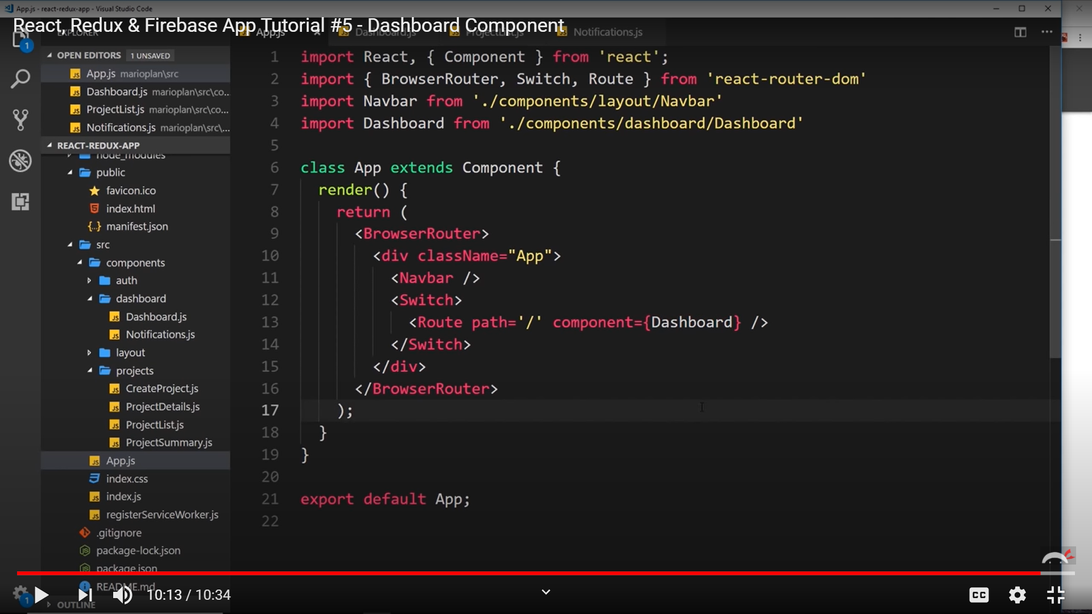

This is how we have to provide the Route with the path and component in the App.js.

1. 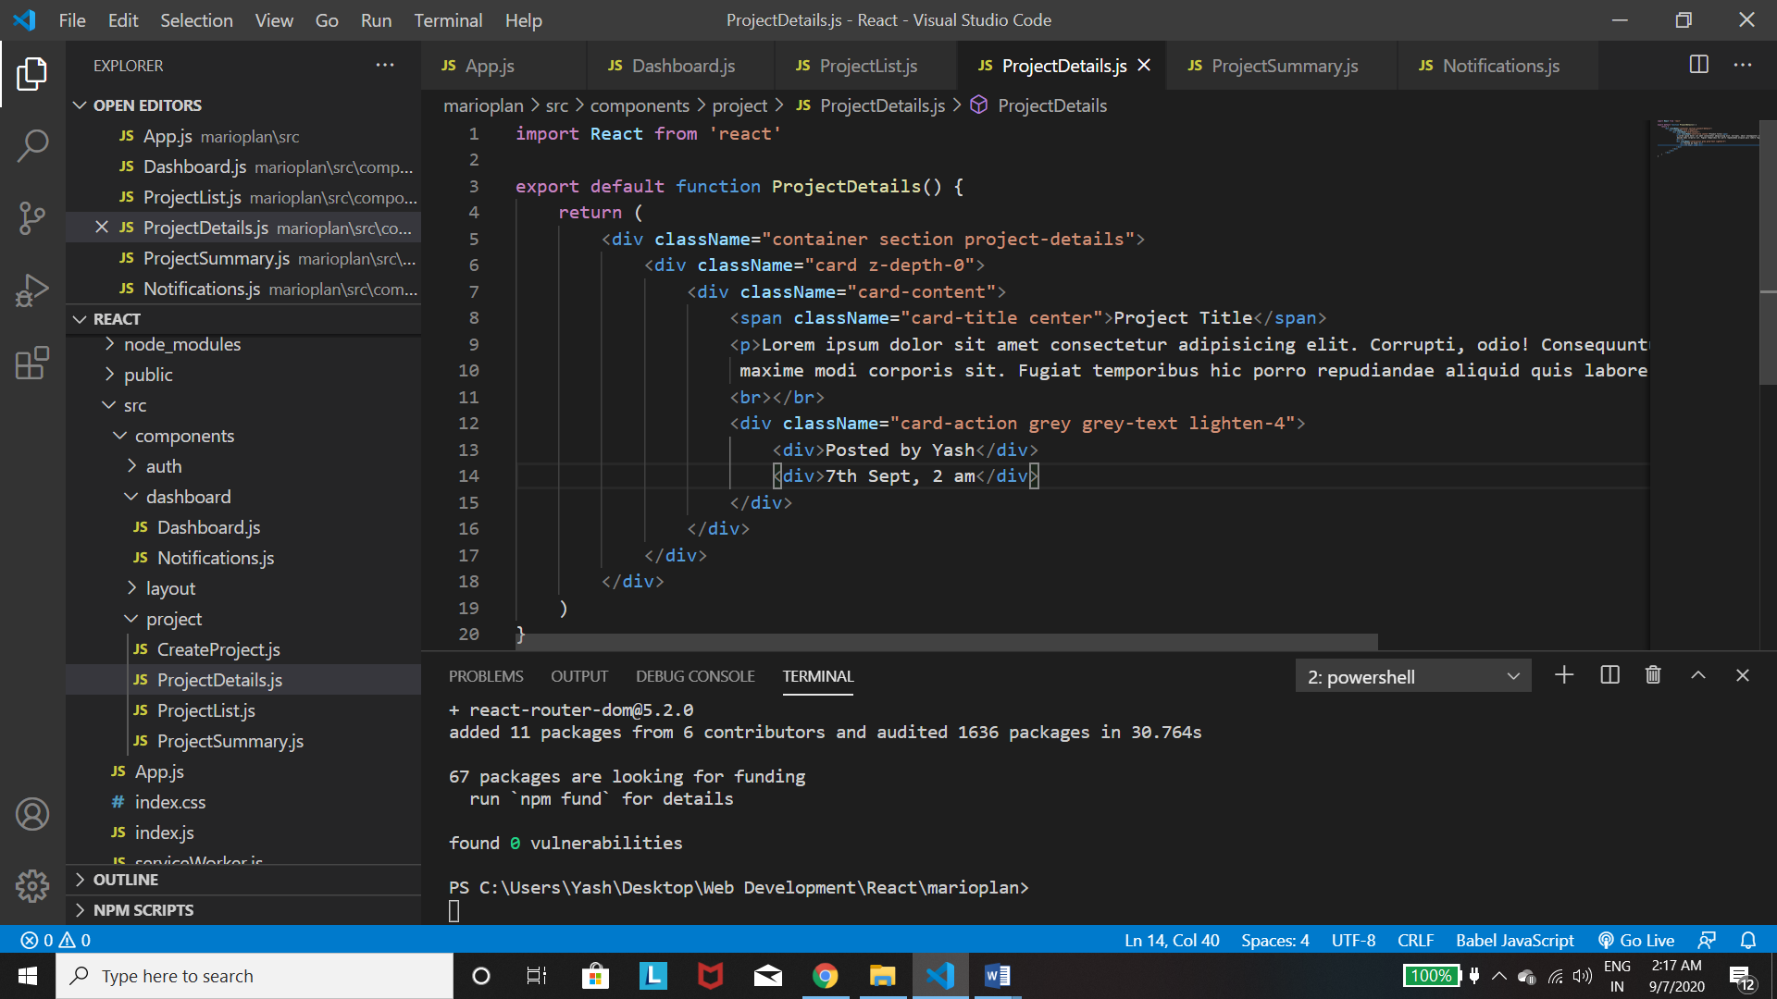

*Card-action*  is the most imp above while the others are derivatives of card.

1. 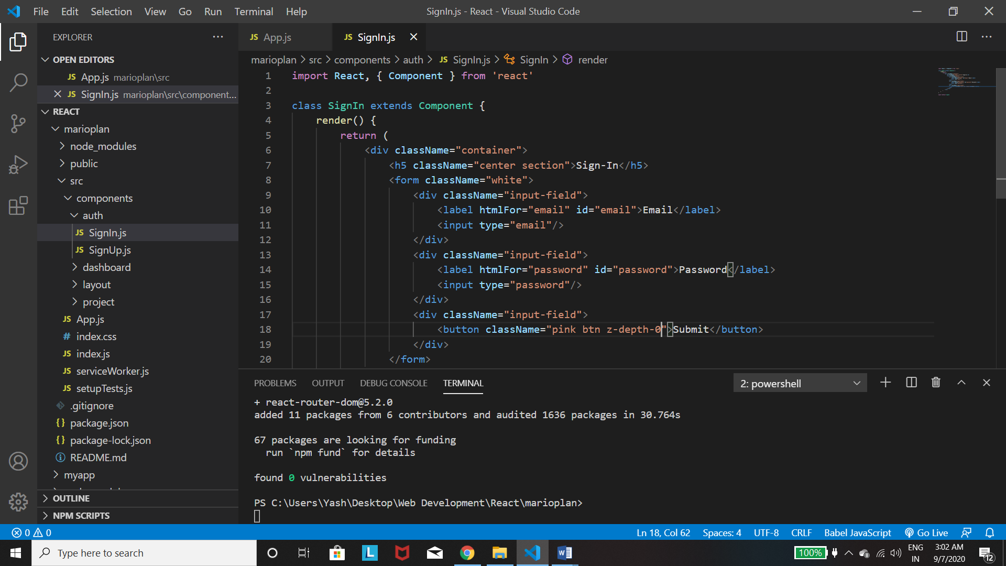

Firstly *copy the js cdn link into the index.html file,* for the input-field to work properly. Then use *input-field div*  on every element you give. *Section* is used for properly spacing the heading.

For the Create Project form , we just need to have a *textarea with className:”materialize-textarea”*  for some styling

1. CSS – The images down below are some imp css properties that we need to apply to have a proper styling. The *min-height:100%* is required for covering the full browser page. The *background-position:bottom* is required for making the image start from the bottom. The *background-size:100%* is required.

The *padding and the margin* is required in the forms. Lastly the final part basically makes the form box coloured when we select it.

* 1. 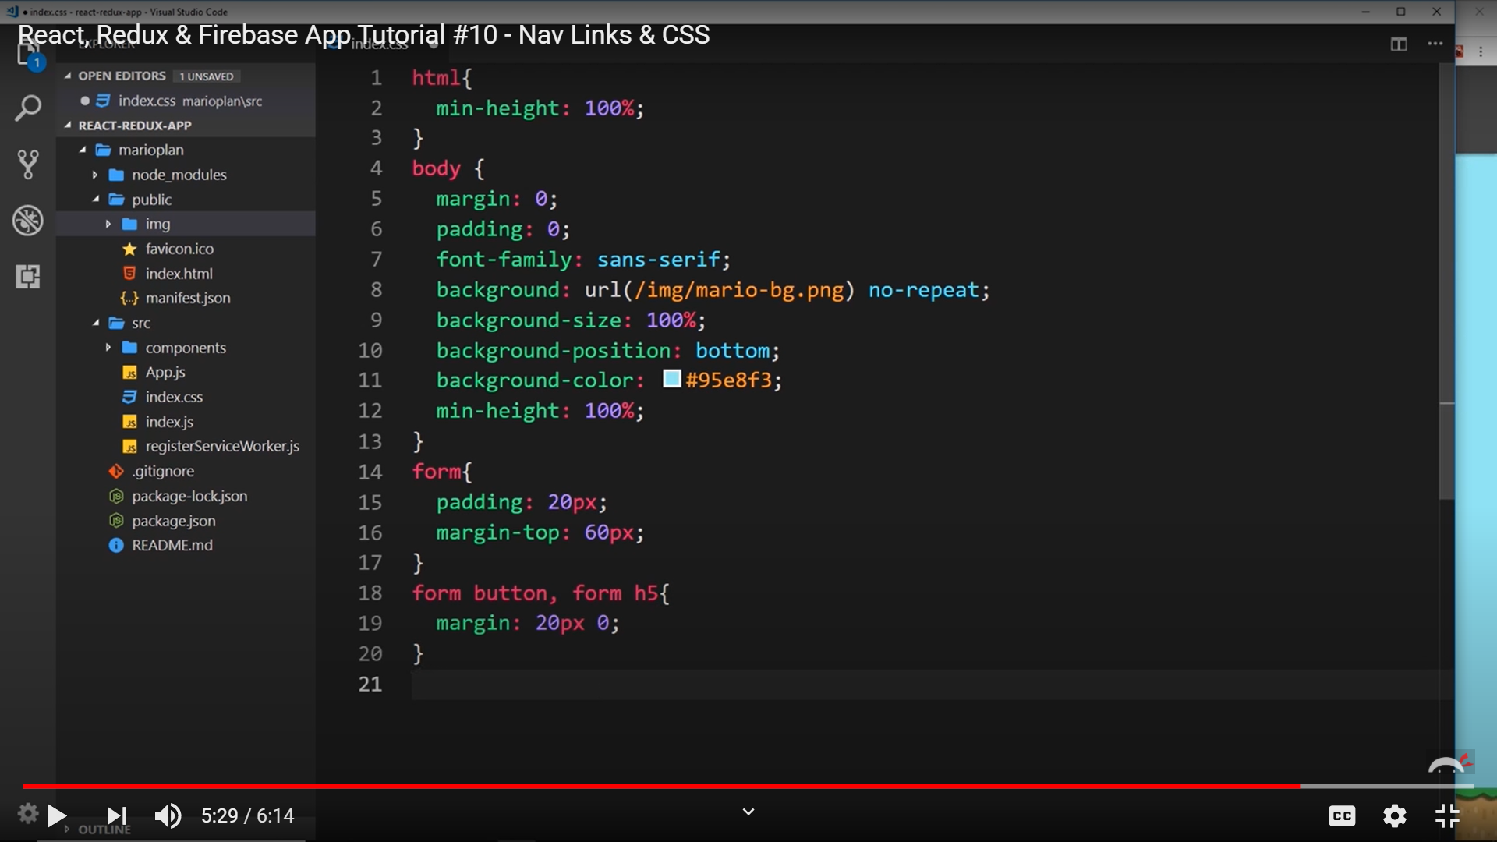
  2. 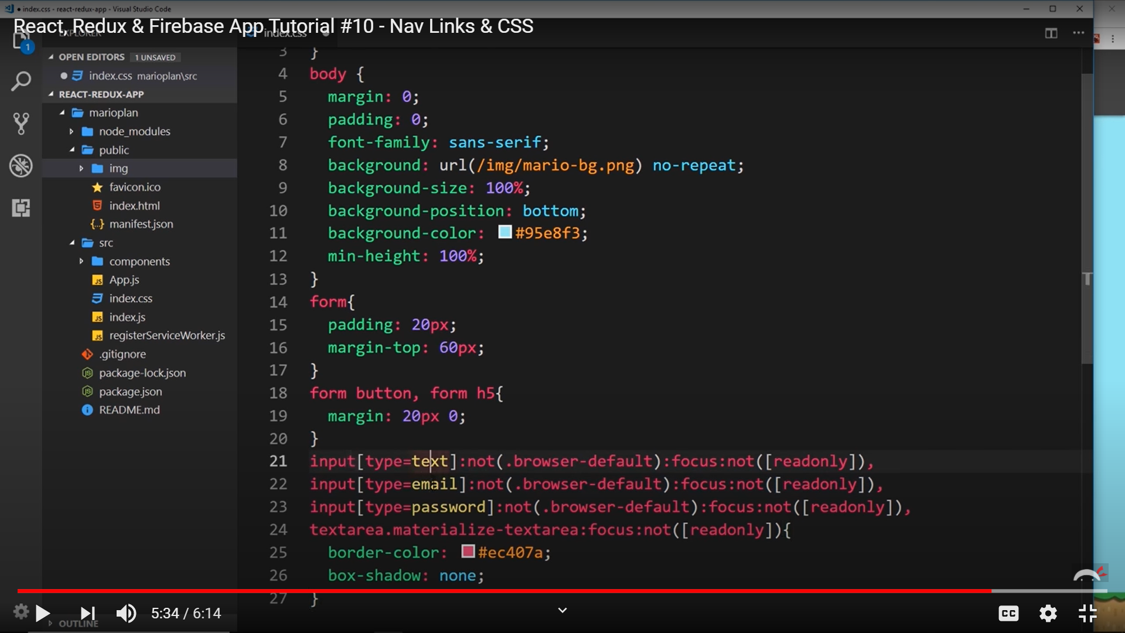

# Redux :

­

1. First import createStore from redux and then use the store to create the store and then use the Provider tag to surround the App and use **store={store}.**
2. Now we will have to make multiple reducers and then combine all of them into a single reducer which we will pass into the createStore function.

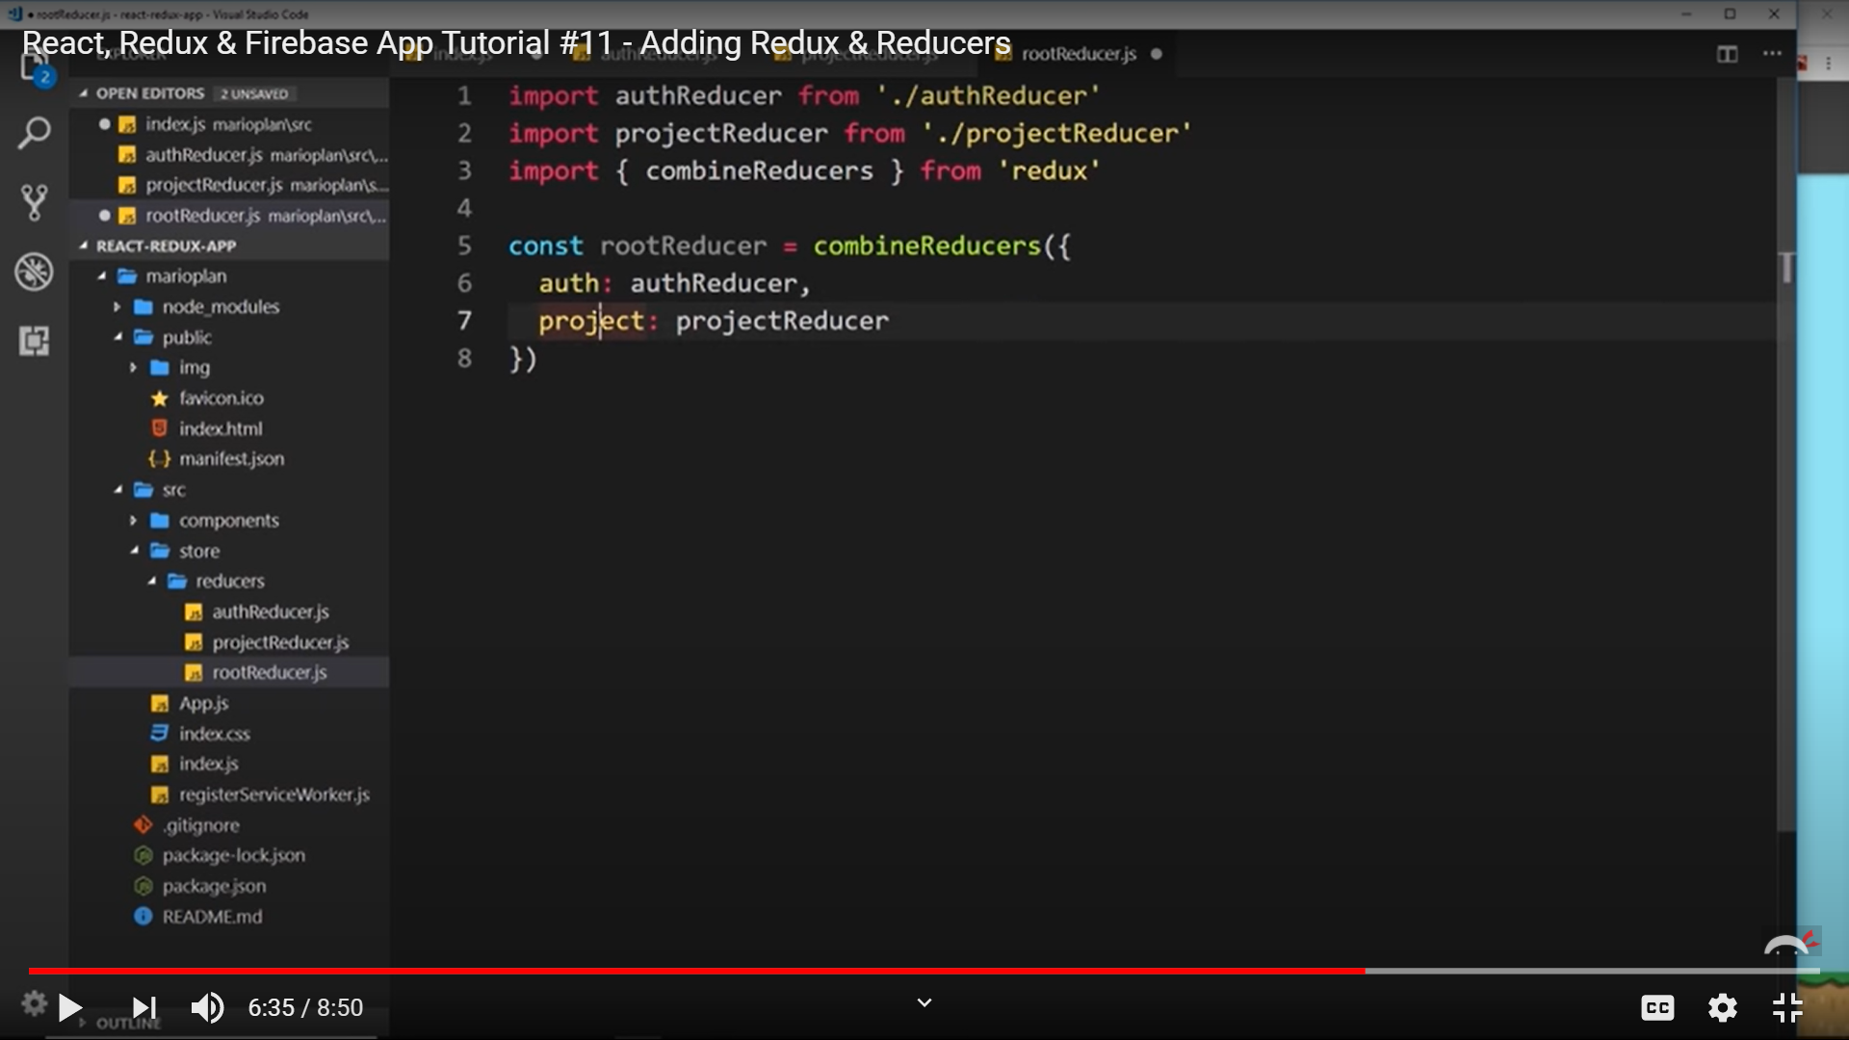

Combining Reducers

**All the imports are from redux except the Provider tag(used in the index.js) and the connect tag (used in the components connections) which helps in surrounding the App tag.**

Don’t **forget to use store={store} in the Provider tag.**

**Also in the connect() , we always have to pass the state before we do the dispatch and for that if we don’t have any state use (null,mapDispatchToProps)**

**Don’t forget to use key={id} when you map through your data. This id must be mapped to the Link tag of the Project Summary.js file as that is the parent element there.**

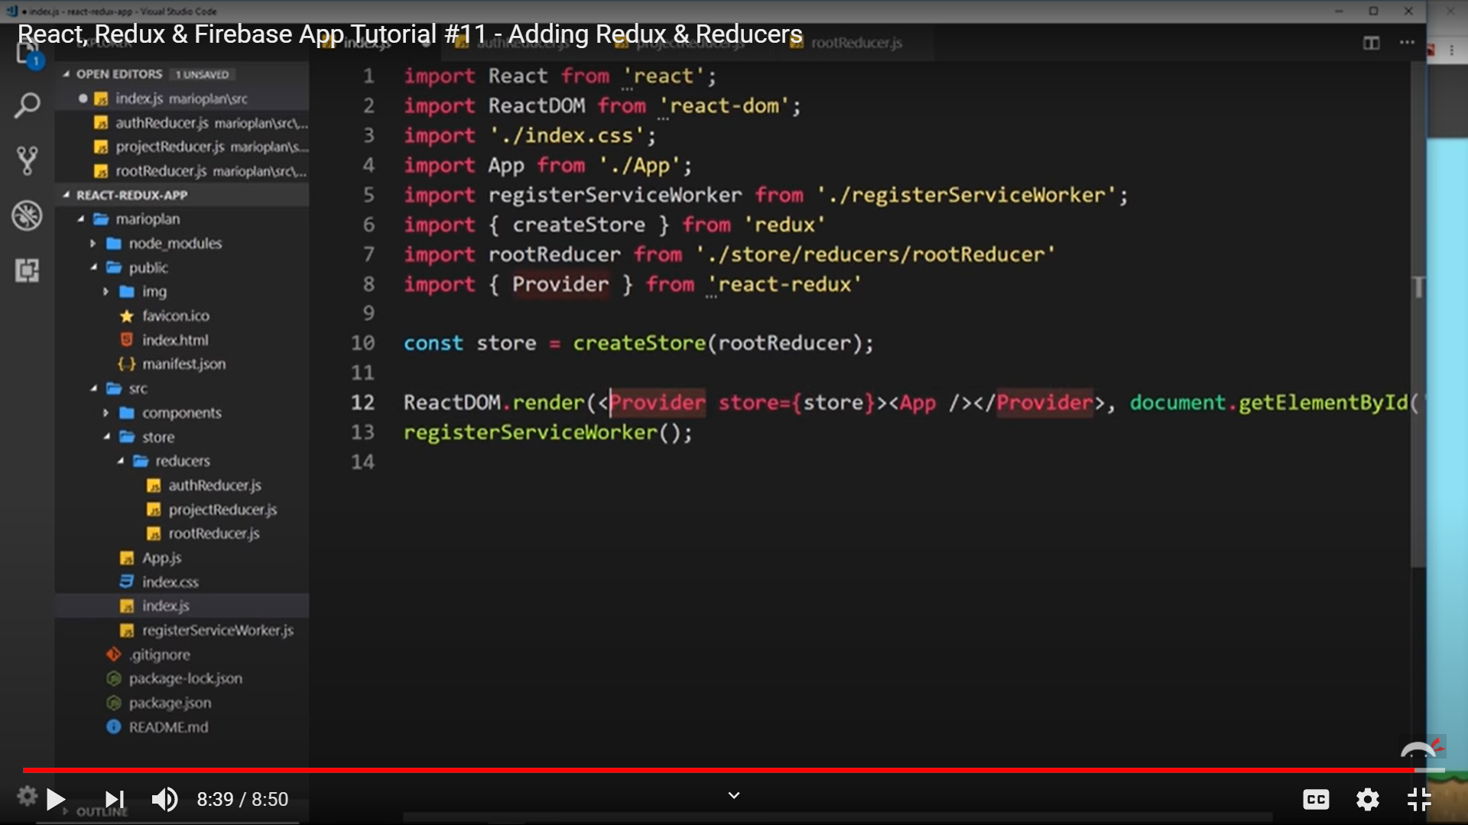

1. Now we use the project in the state to get some dummy data from the ProjectReducer in the Dashboard.

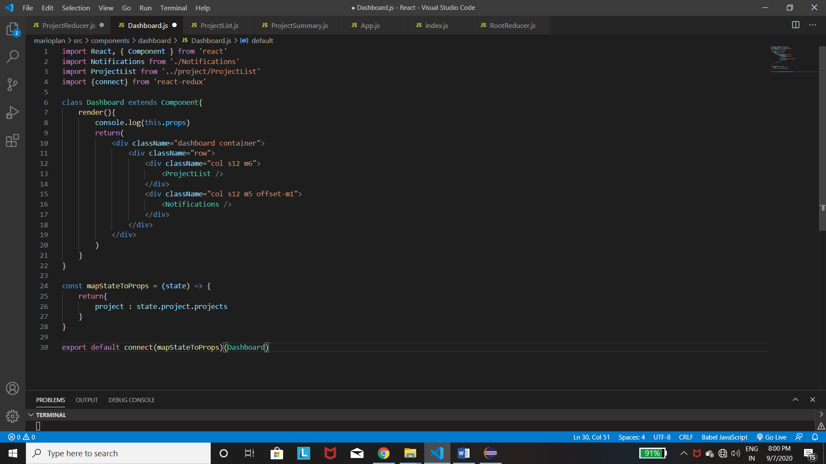

Then passing this data into the Project list and then mapping through each data and then returning the ProjectSummary with the project as a prop and then accept the prop in the Project Summary and then print it.

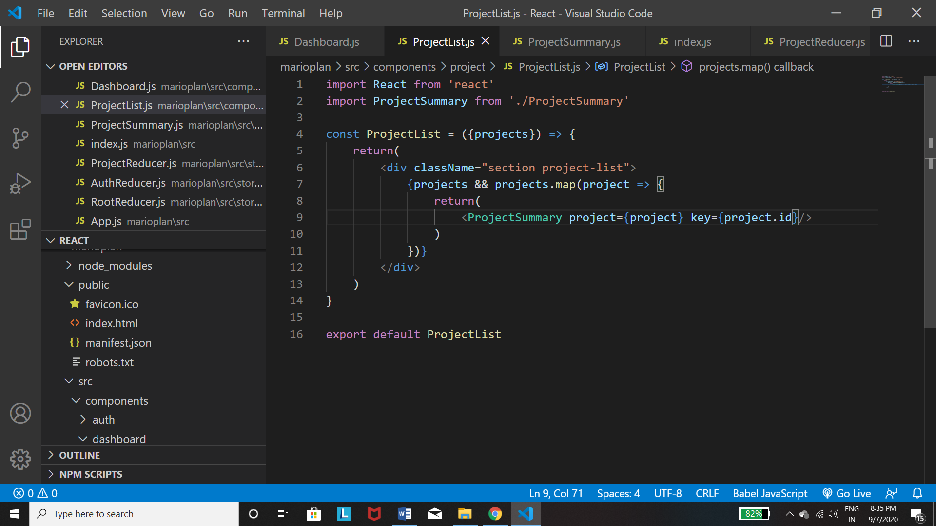

Above shows how to map and return the ProjectSummary with the id.

1. 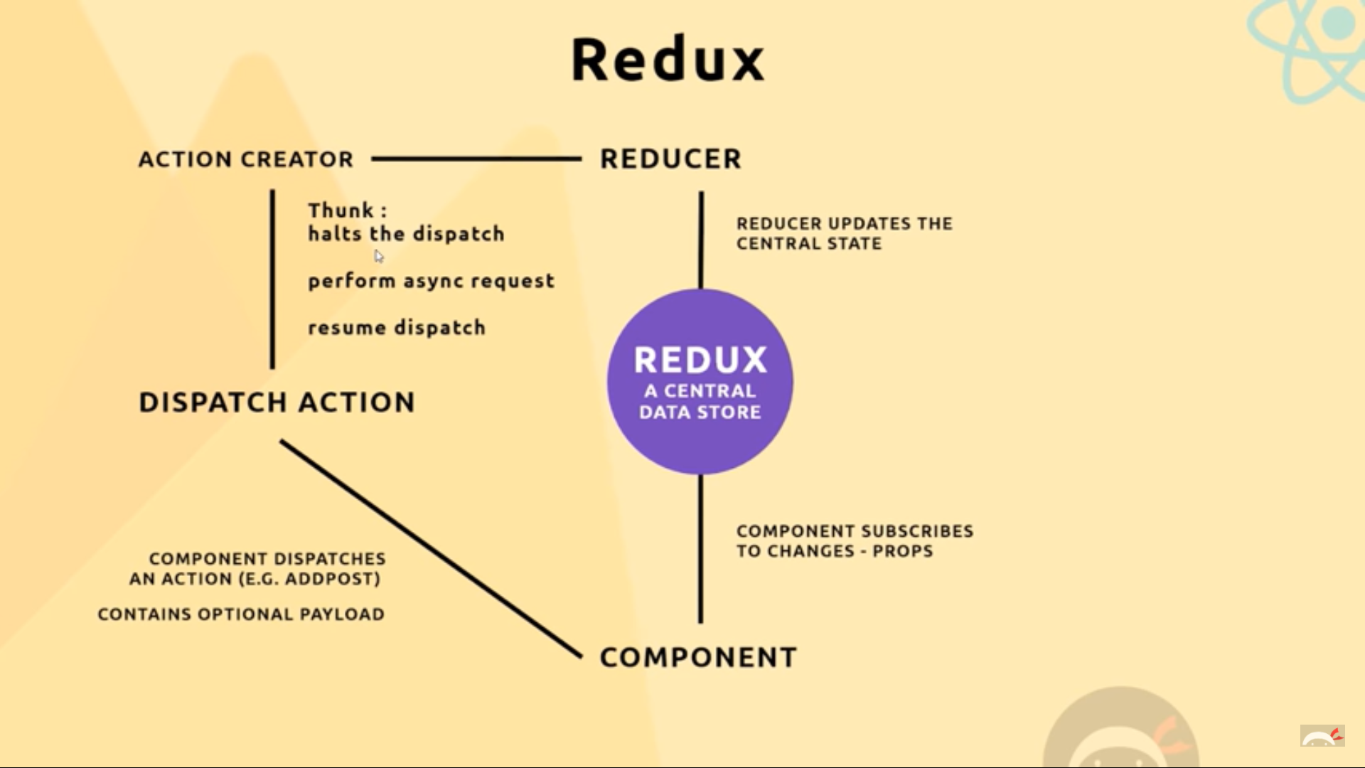

Now we need to grab data from an external source and we though can do it from Redux->Component path and Reducer->Redux path but we have the best way of doing this when Dispatch->Reducer happens. In this we can instead of the action pass the action creator and by the use of **Redux Thunk** use it to halt the dispatch and grab the data and then continue.

1. Redux Thunk –
   1. Firstly install redux-thunk(npm). Then import thunk from redux-thunk. Then import applyMiddleware from redux. Then use the middleware as a parameter in the createStore function with thunk as a parameter of the ware function. So basically the entire thing becomes store enhancers and we can have many of them.
   2. Now we can make the projectActions(action creator) and then we usually return the object as type and another add-on(like id or project). But with the help of thunk we can return a function. This function takes (dispatch,getState) as parameters. Now in this we will definitely return the object as we do but before that we can have some asynchronous calls to our database and at this palce we see that the function halts.

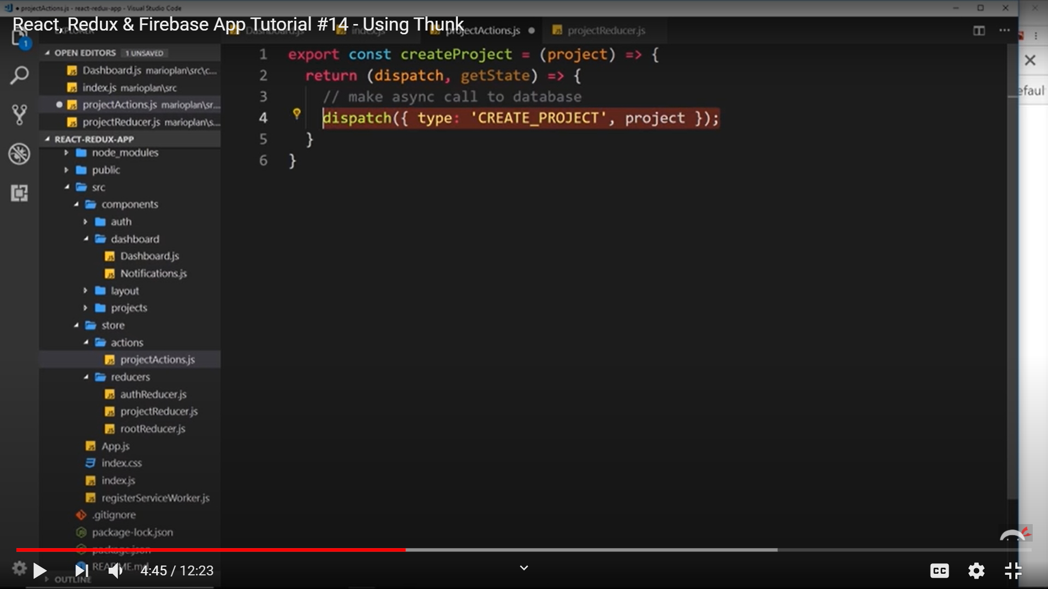

1. FireBase – Create new project on the site and then copy the Initialize key features of the project and paste them into a new file in the config folder and make the following changes :
   1. Firslty import firebase from ‘firebase/app’ , import ‘firebase/firestore’ , import ‘firebase/auth’
   2. At the end write : firebase.firestore().settings({timestampsInSnapShots:true}) [**NOT REQUIRED NOW]**
   3. Finally export.

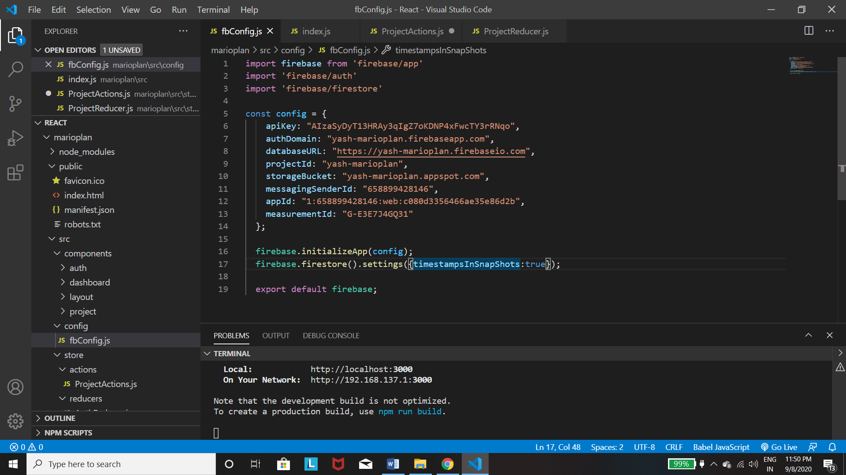

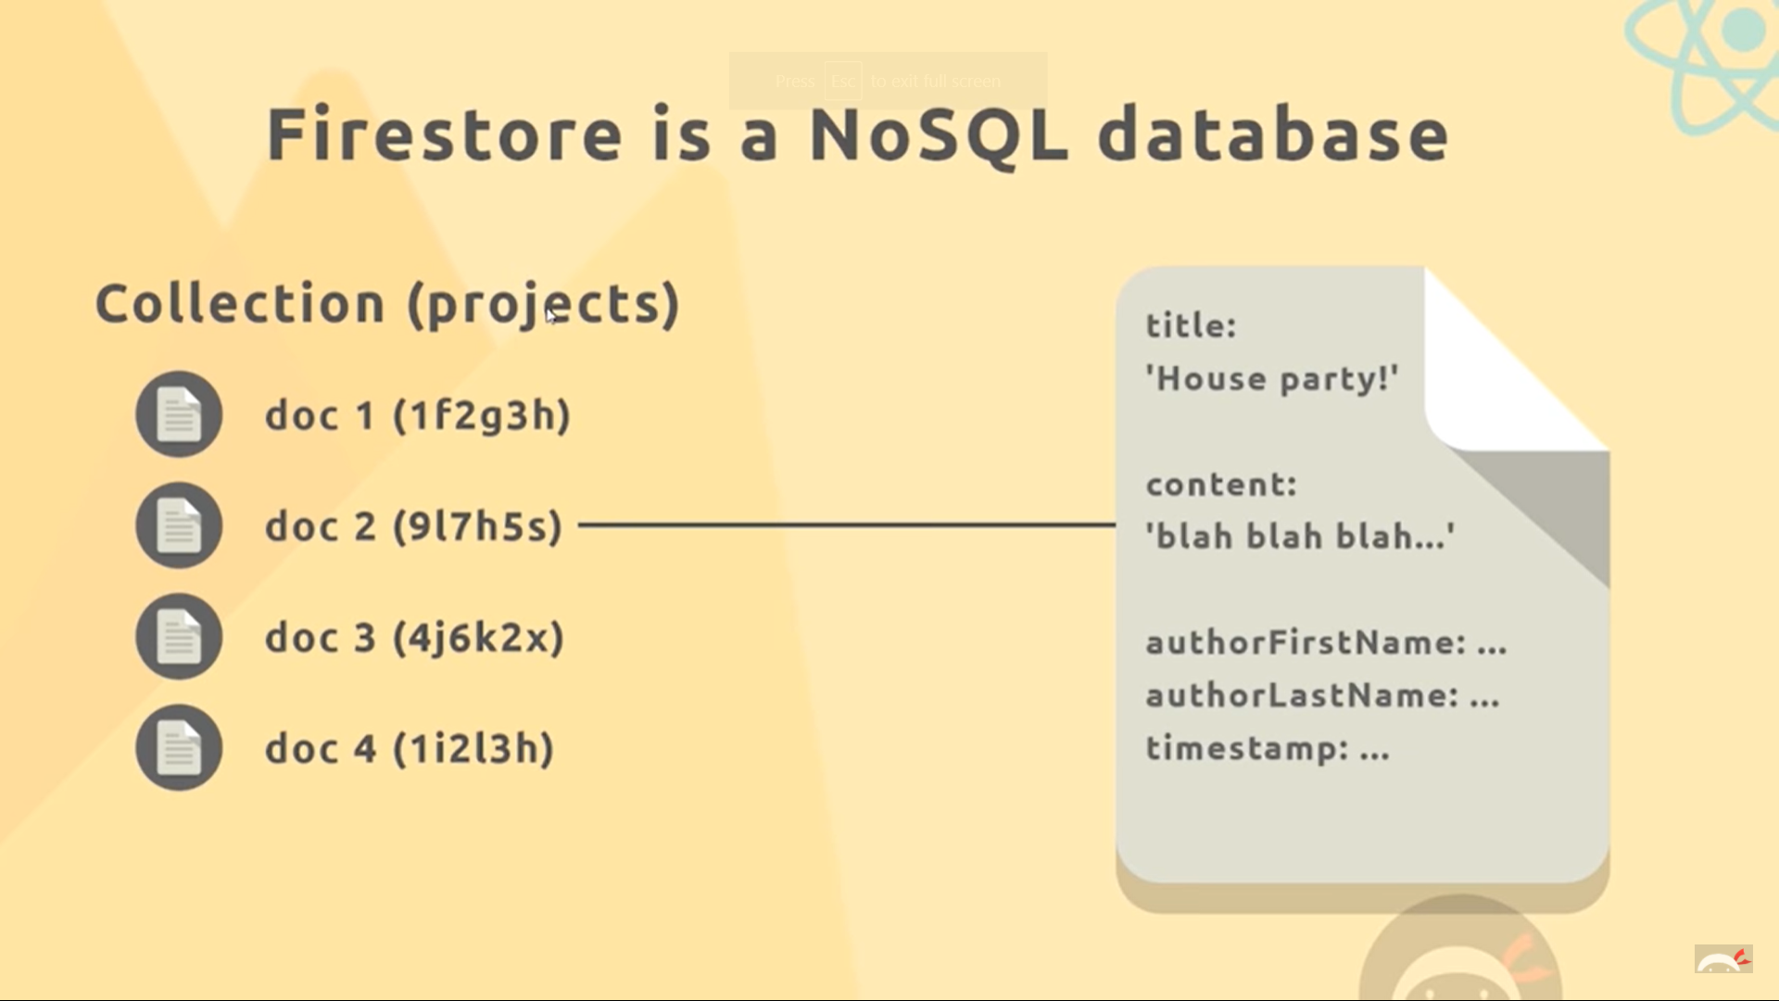

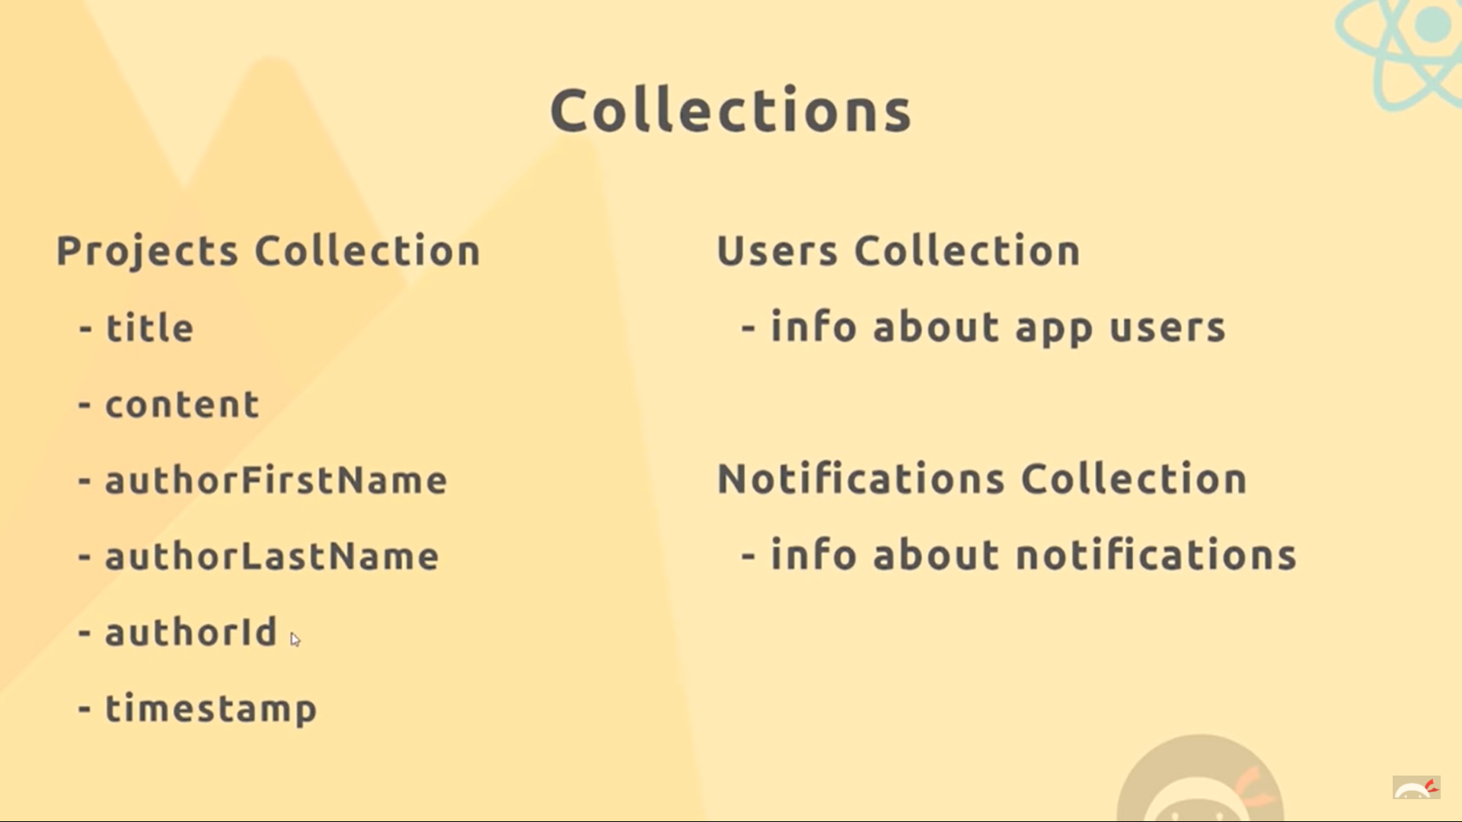

* 1. For adding a dummy document inside a new project head to -> Firebase -> Database and create new collection and add the fields you require.

1. Connecting Firebase –
   1. First install and import getfirebase and getfirestore int index.js‘react-redux-firebase’ and ‘redux-firestore’
   2. Optional : npm clear cache --force

and then it's ok you can do

npm i firebase@^4.8.0 --save

* 1. **Use “npm i --save react-redux@5.1.1** [**react-redux-firebase@2.2.4**](mailto:react-redux-firebase@2.2.4)**” to install react-redux-firebase else it wont work**
  2. Then we need to use thunk.withExtraArgument({getfirebase,getfirestore }) as objects and then receive them as objects via destructuring in the projectReducer.
  3. Now the applyMiddleWare is a store enhancer and similarly for connecting firebase to redux we need a store enhancer. Now for using multiple store enhancers we have to use ‘compose from redux’ as we used ‘combineReducers’ for using multiple Reducers.
  4. Then import reduxFirestore and reactReduxFirebase and use them as store enhancers and pass the config file after importing to them.
  5. Refer to the diagram below for more clarifications.

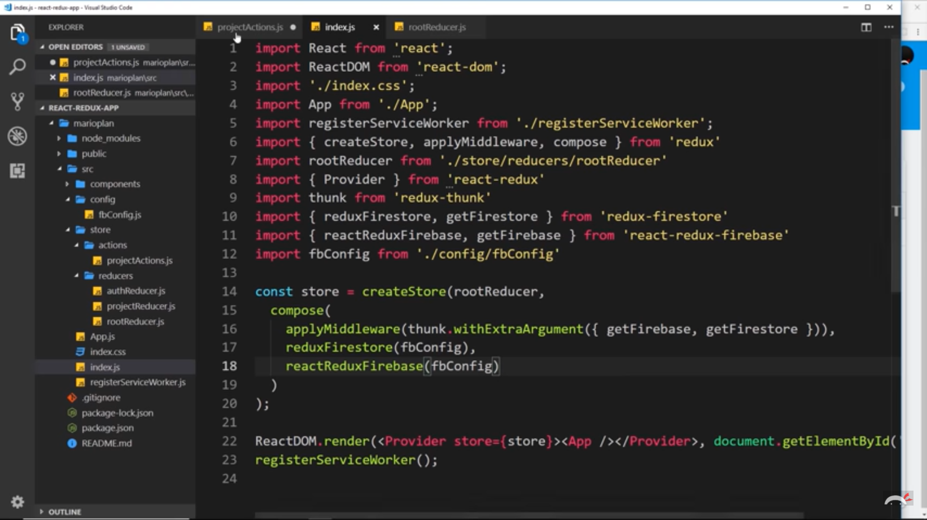

1. Uploading Project to Firestore :
   1. Firstly in the projectActions make the const firestore = getFirestore().
   2. Then use this to refer to the firestore. Then firestore.collection(‘collection_name in your firestore’).add({The project to be added)}. then(()=>{dispatch…}).catch((err)=>{..}
   3. The last catch is used to catch the err (if any).

See the pictures below very carefully and check all the syntax as they are really important for making things go the right way and adding a project we create in our site to our firestore database collection.

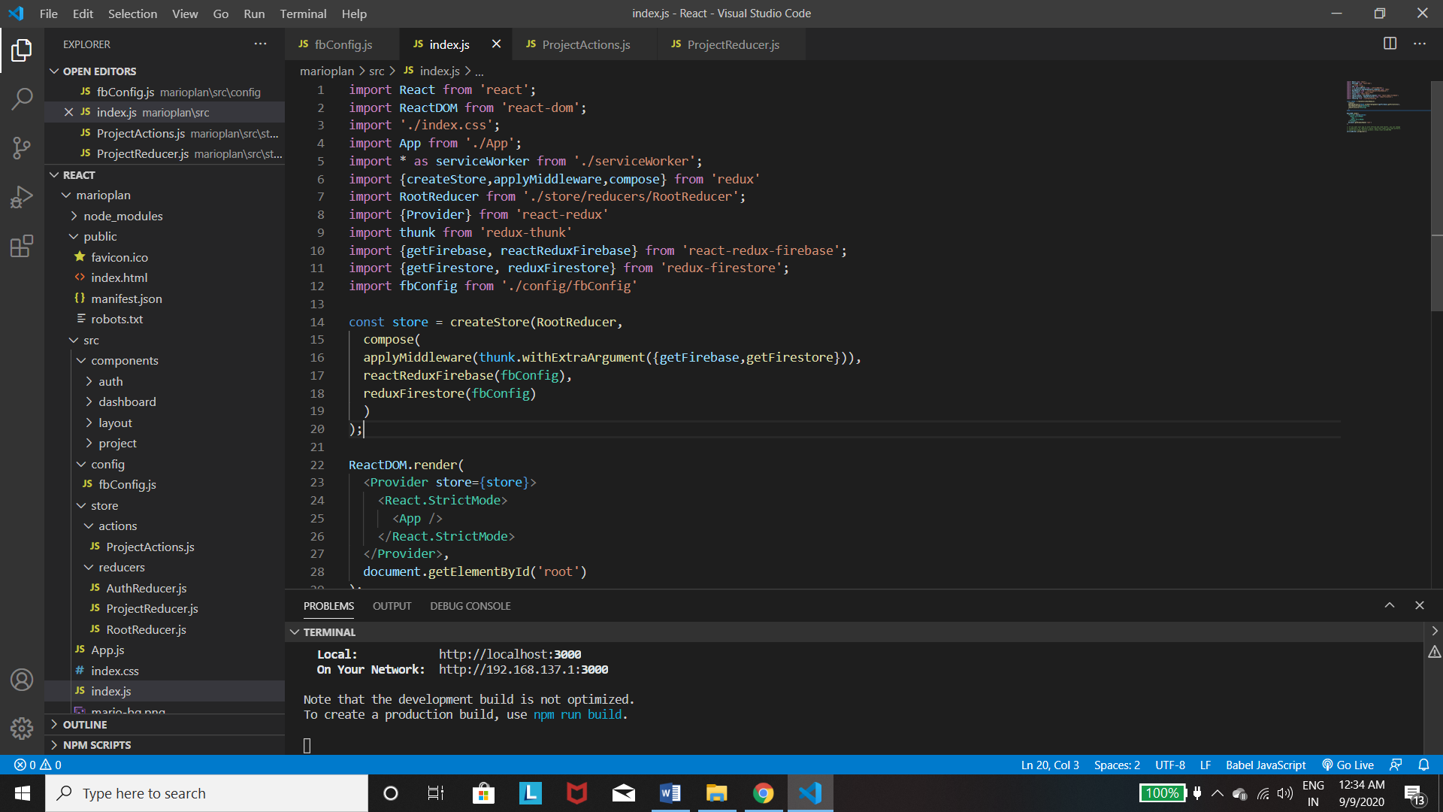

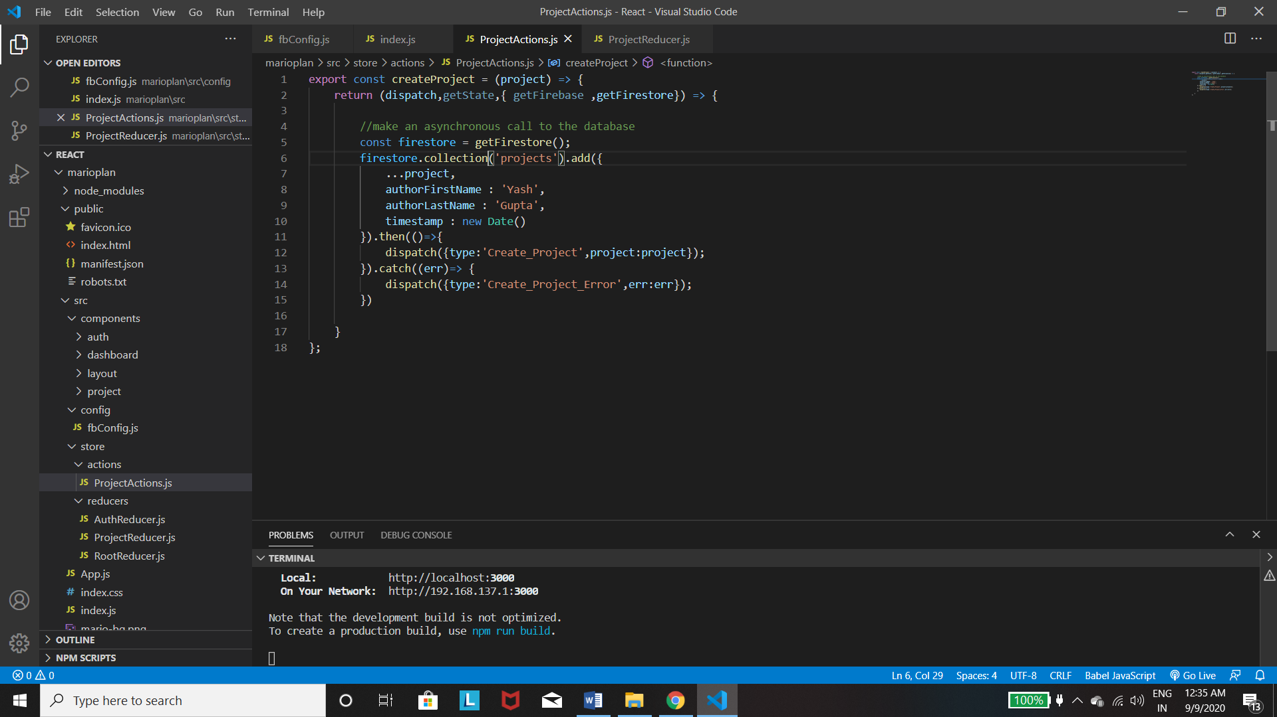

1. Syncing Data from Firestore to our Page :
   1. Firsly import {firestoreReducer } from ‘redux-firestore’ in the RootReducer and then take that reducer in firestore:firestoreReducer.
   2. Then go to the Dashboard where we want to use the data and then import {firestoreConnect} from ‘react-redux-firebase’.
   3. Now we need to connect this to the component as a HOC(higher-order). But we already have one connect. So to use more than one we have to use {compose} from ‘redux’(as we saw in case of store enhancers)
   4. *Now when we have connected the firestore using compose and it takes an array of objects as a parameter, in which we write collection:’project’ which needs to be retrieved from the firestore. Then this data gets added to the reducer which can be access via the state of the redux.*

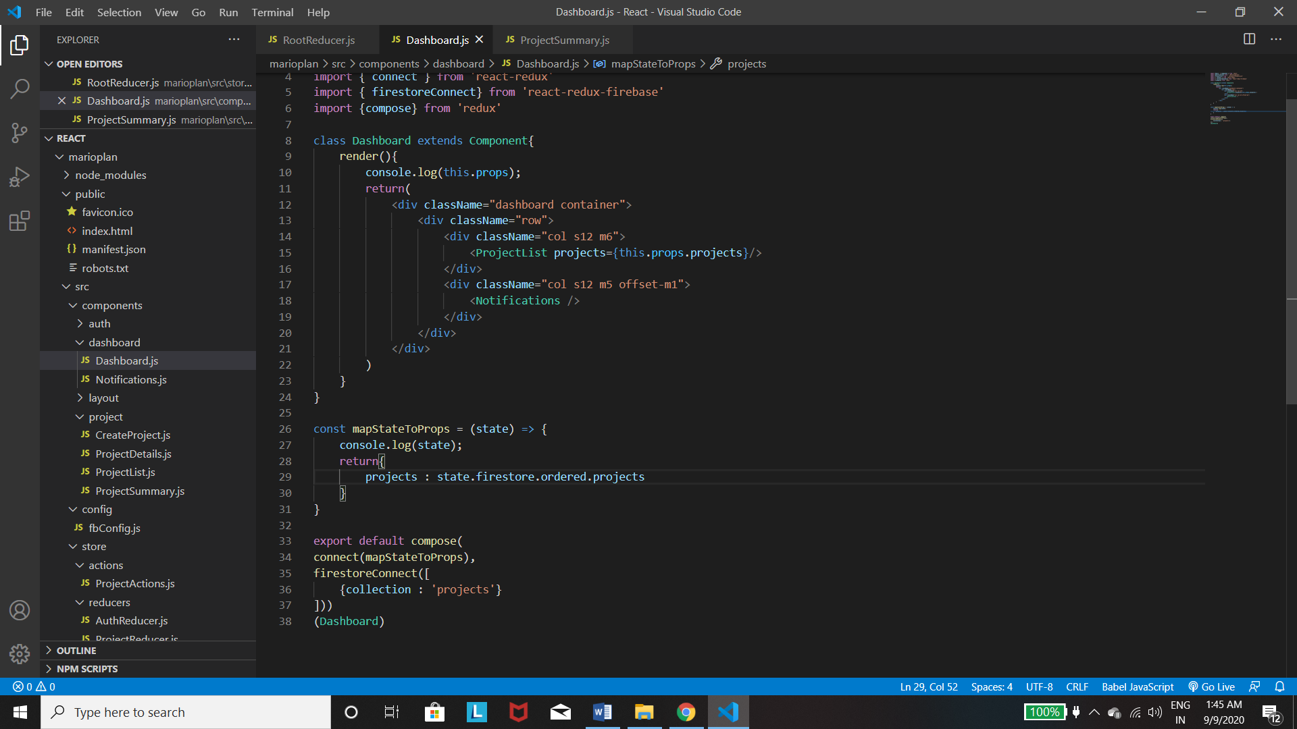

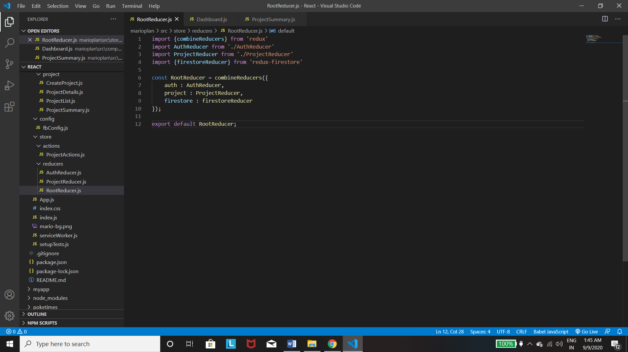

1. Project Details(On Clicking the Project) :
   1. Firstly we need to connect the firebase and the redux using compose so that we can use the data from the firestore. **The firestoreConnect adds the data to the Store and we can use it via the redux mapStateToProps.**
   2. Then use **ownProps** in the mapStatetoProps which is responsible for getting the id of the project.
   3. Then using the firebase we get the projects.
   4. Finally using the ternary operator line we can get the project with the specified id.
   5. Now when using the data , you need to destructure it before using the data as it is a object. So we **use const {project} = props** for that and then we can use the *project.title* to get the title.
   6. Add an if condition to display a message when the project loads.

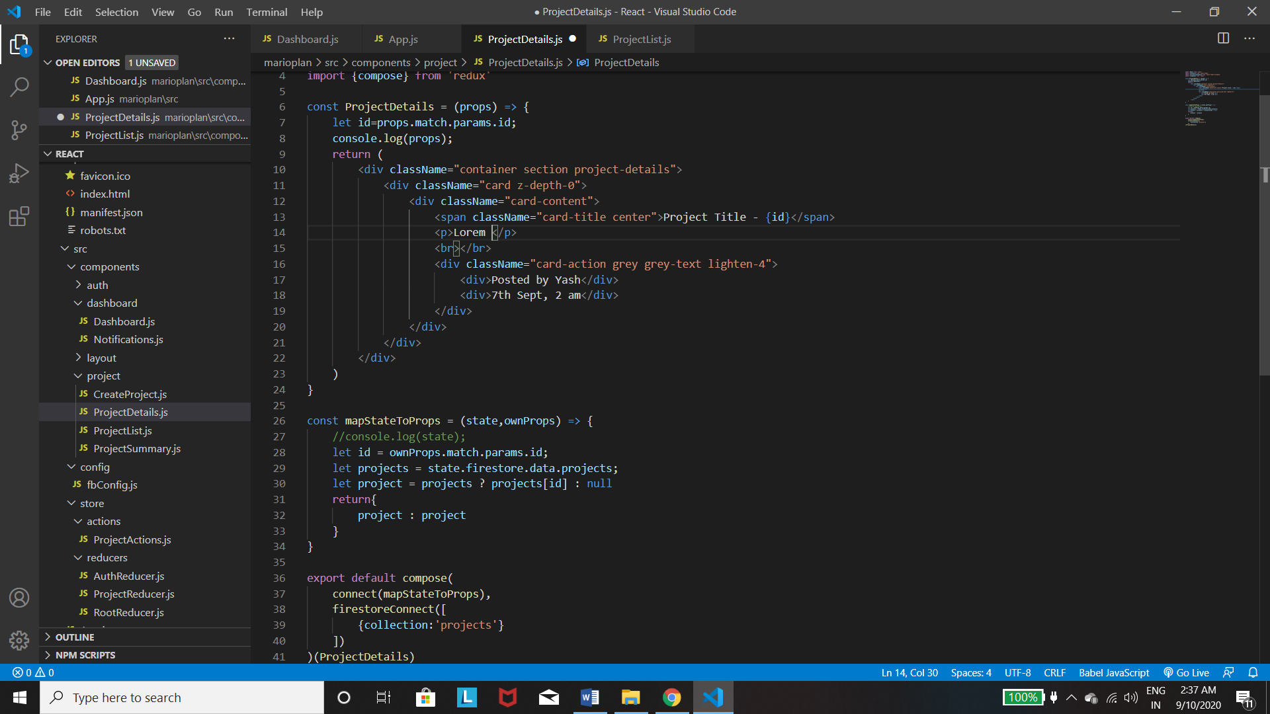

How to get the project of a particular Id from an object of projects.

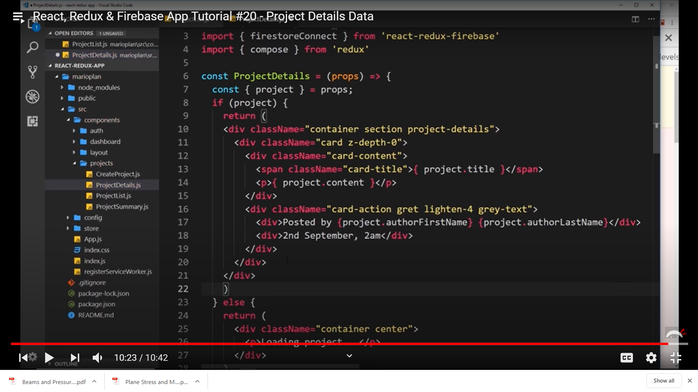

How to get the project from the props using destructuring and using it.

# Firebase Auth

1. 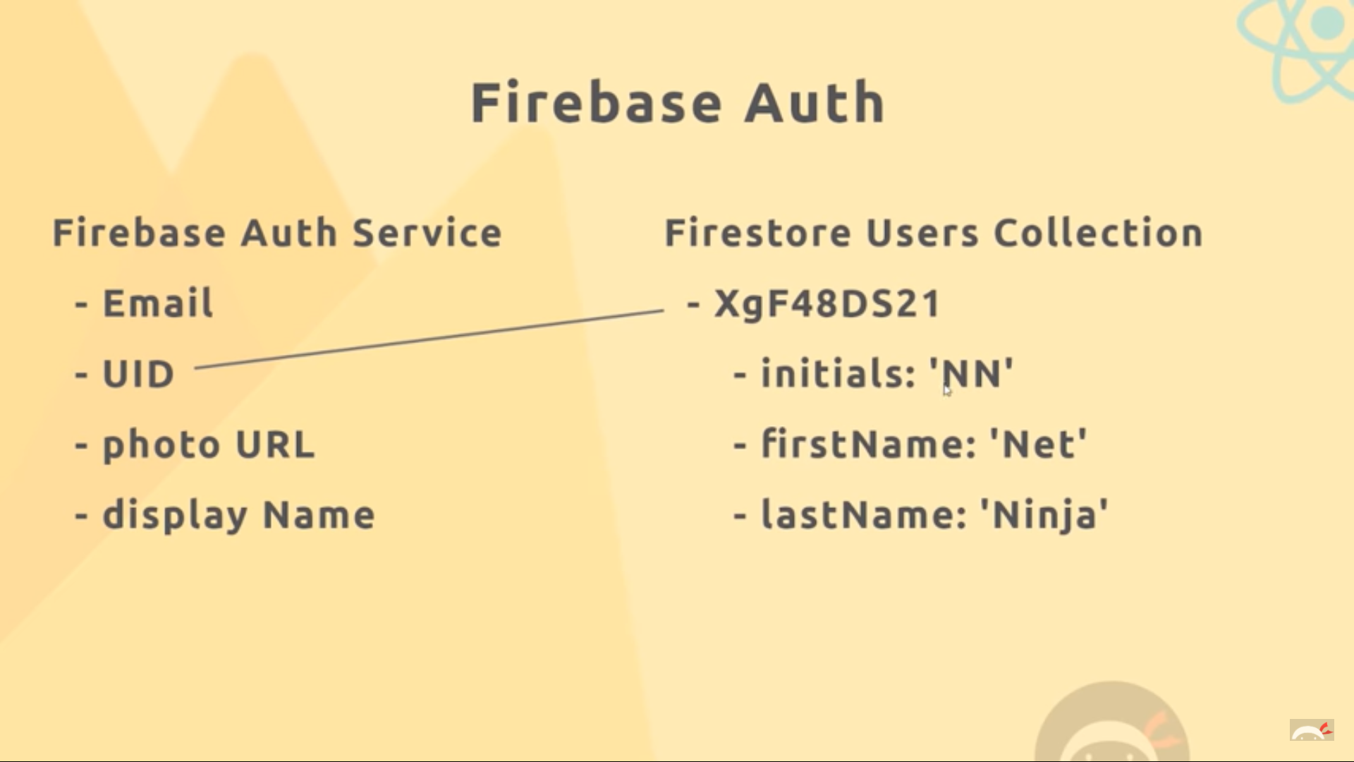

This is the basic idea which we will follow that being the UID which will be generated in the auth process will be the name of the doc where we store the info about the user.

For setting up : Just use the Authentication in your firestore and Enable the Email.

1. Connecting FireBase auth :
   1. We import the firebaseReducer from react-redux-firebase and keep it in the firestore in the rootreducer component.
   2. Then when we connect the components to the state we will be able to view the firebase which will help us to show whether we have logged in or not.
2. Logging In :
   1. 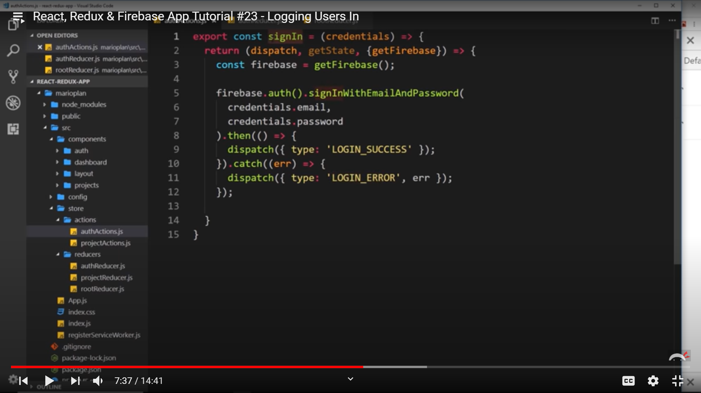

The asynchronous call to the firebase

* 1. 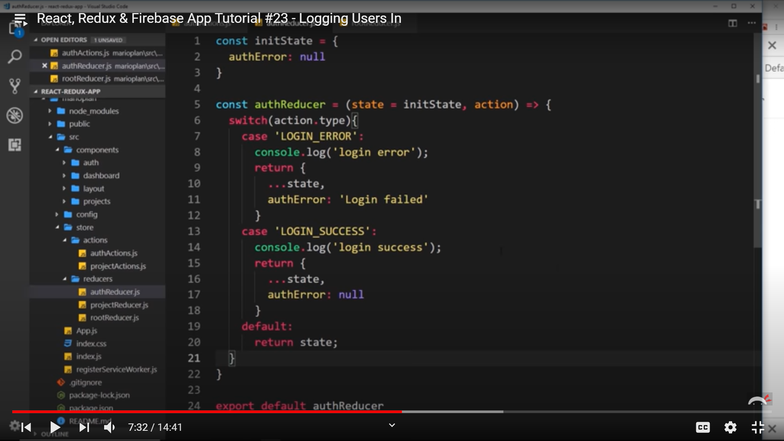

The dispatch into the authReducer.

* 1. Then go to the SignIn component where we will use them. Then import the connect and connect the SignIn with mapDispatchtoProps to the function signIn in the actions. Then you can use the function in the submit function via props and pass the state in which we receive the email and password from the user.
  2. Then we get the authError from the mapStateToProps and destructure it and use it to check whether its null or not and display and message accordingly. If it has message print the message else leave it to null.

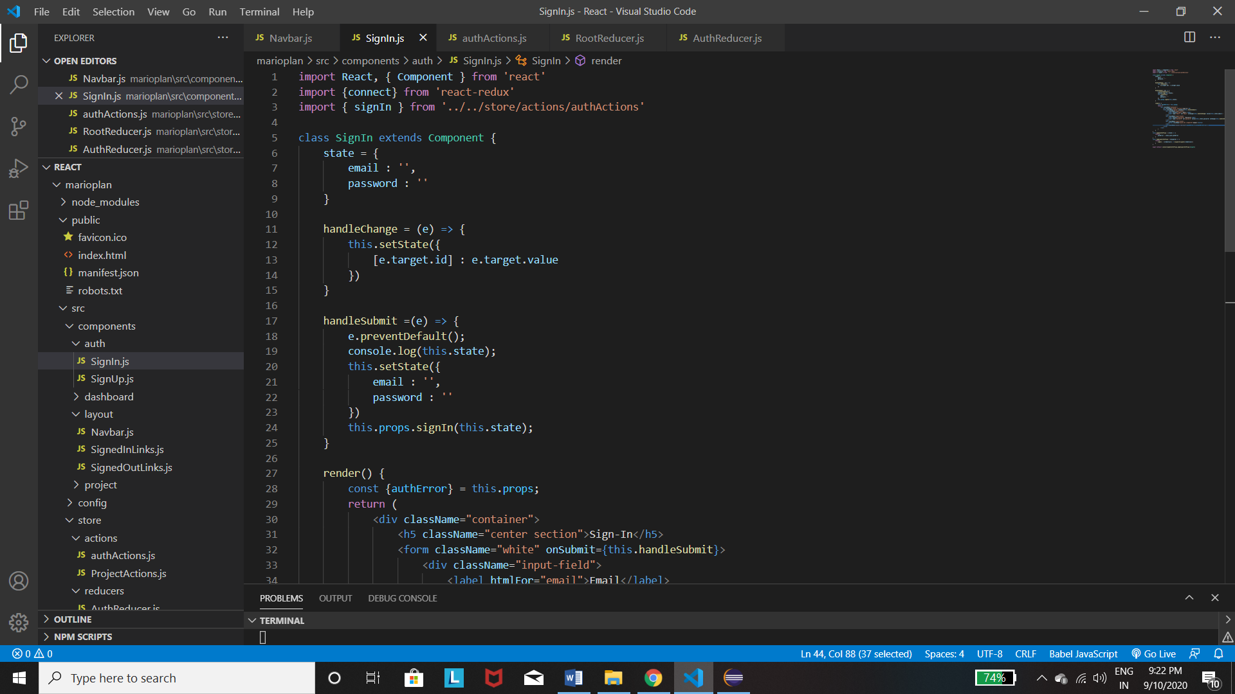

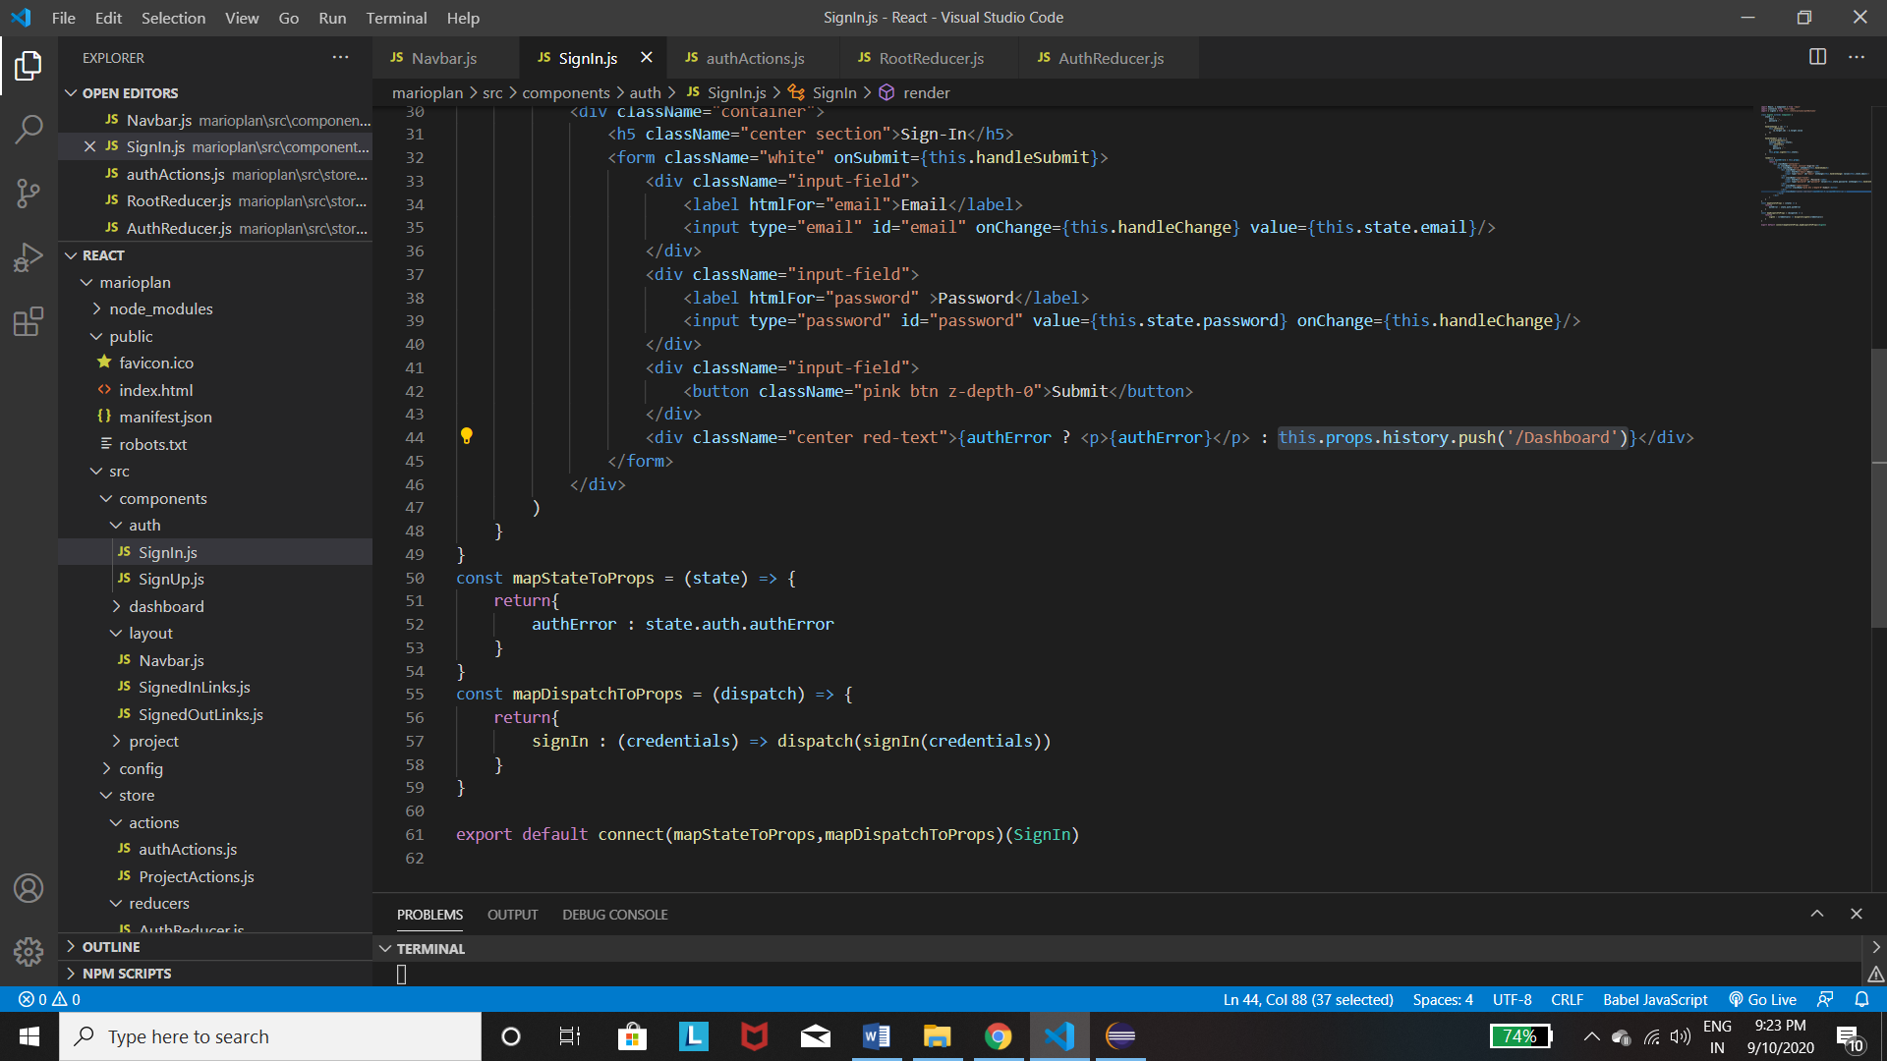

1. Logging Out : Use the functions from authActions to logout and use the connect to use the function.

xxxx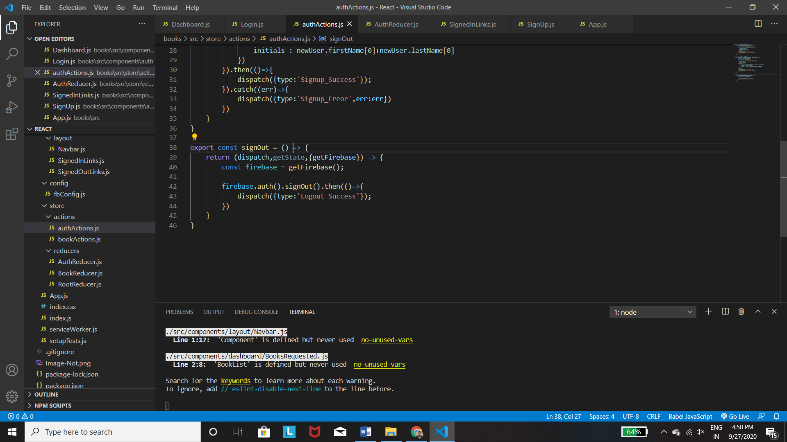

1. Tracking Auth Status :
   1. Use the auth.uid operator existence in the firebase as a check for the status.
   2. Use the ternary operator for printing the necessary links at one time.

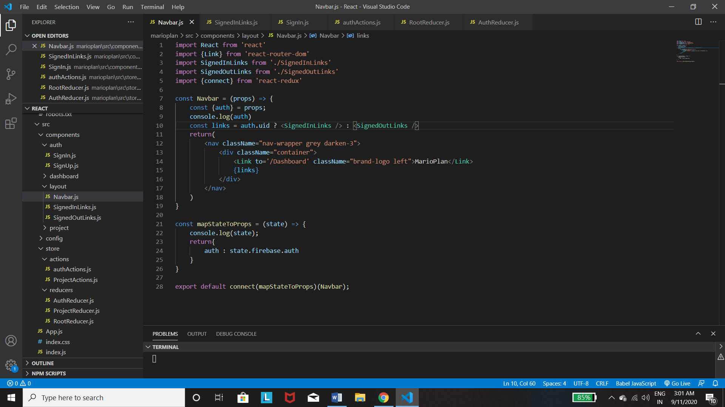

**Note : Here the {auth} = props and not {auth} = props.auth**

1. Waiting for Auth Ready – Now when we reloadthe page then the dom render the page before the firebase auth is initialized and so we get SignOut links before we get Singin links . So we need to :
   1. Firstly use {attachAuthIsReady : true } as a second parameter in the index.js file in the reactReduxFirebase.
   2. Then use the store.firebaseAuthIsReady.then to render it after.

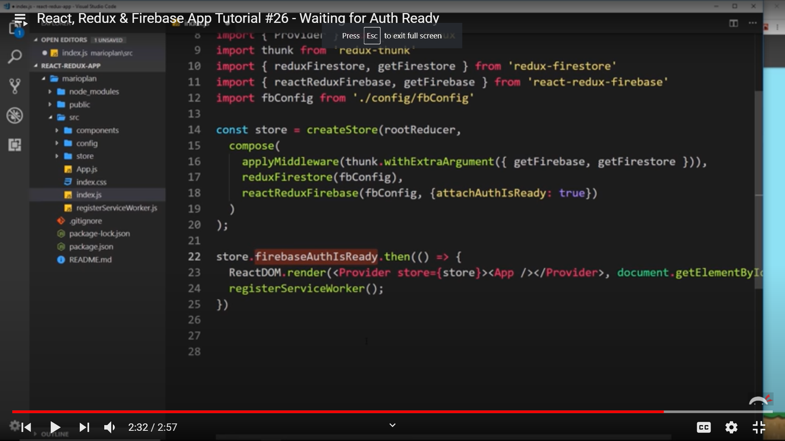

1. *Guarding Routes :* 
   1. *Now we don’t want the DashBoard be shown to the user if he’s not logged in.*
   2. *So we first get the auth from the mapStatetoprops via state.firebase.auth. Then destructure it. Then check if(!auth.uid) exists or not.*
   3. *If not then not logged in and the Redirect the user to the SignIn page using - <Redirect to=’/signin’ />.*
   4. *Before doing the above use the* ***import {Redirect}*** *from react-router-dom.*
   5. *Now use the above strategy on all the components you want to show only after logging in.*
   6. *Also for those which you have to show after logged out.*
   7. *Like guarding all those components with the Redirect for which you want to prevent them from going to signin page when they are already logged in.*
2. **Sign UP –** 
   1. 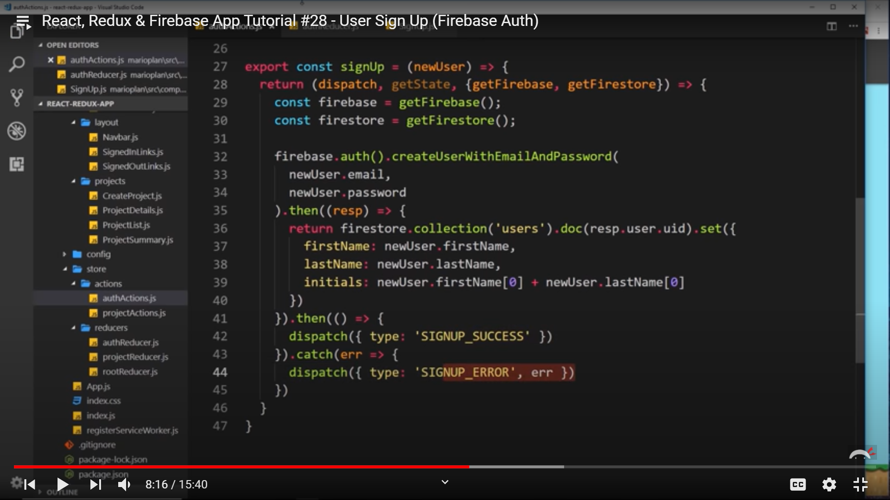

We need both the firebase and firestore here. Then we use the auth(). To create the user and then we have to return firestore as we need the **uid**  from the response of the creation. In the return we use the collection(‘users’) which it automatically generates if not present and then use **doc** insead of **add** as we want to create with a particular id which is resp.user.uid and then set the fields in the doc. And then dispatch it finally.

* 1. Now in the Reducer , put the 2 cases in the form ‘Signup_Success’ in the authReducer.js in which we will first log to the console a message and then return { …state, authError : null / action.err.message}
  2. After this go to the SignUp and use **mapDispatchToProps to dispatch and connect the signup in the props and use it.**
  3. Also use the authError and import that from the state put that in authError. Then destructure it and use the ternary operator to print the message If any else keep it to null.

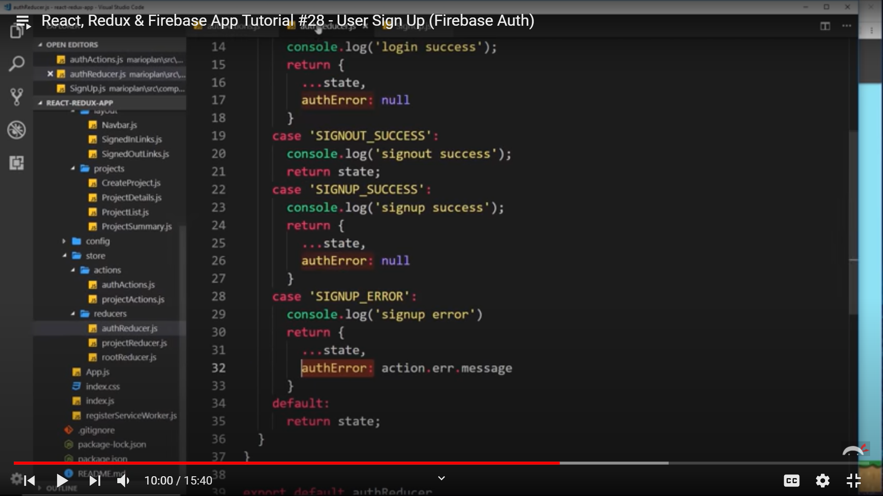

1. User Profile Data :
   1. Now we can use the firestoreConnect to get the data but instead we have a better solution as firebase provides us. It already has the uid stored in the state and it also has **profile** in which we can get the data of the user by adding the following statement in the index.js file in the reactreduxFirebase store enhancer : Look at the picture below

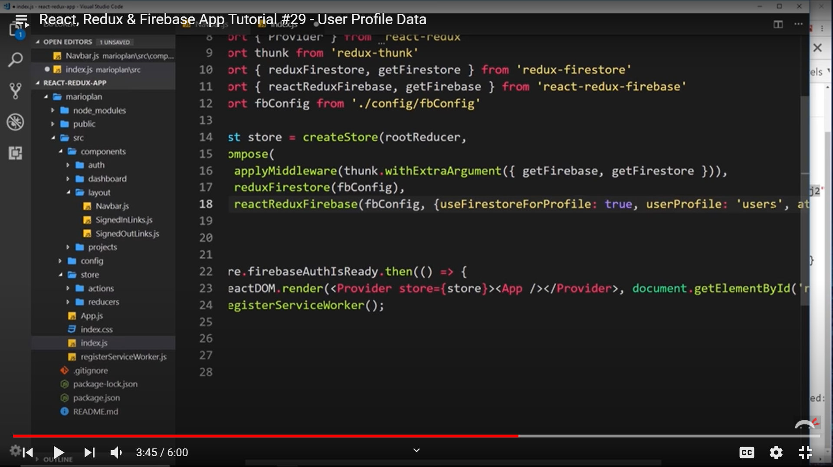

1. Creating Projects(Revisited) :
   1. Now we have the user data who created the project and now we use this info in the projectAction.js to input the first name , and last name from **the getState().**
2. Dates :
   1. Now we can easily add the date via the timsstamp we have created in the docs, using {project.timestamp.toDate().toString()} , String as its an object.

But we don’t really do that, and use momentjs for this purpose.

* 1. Firstly ,install moment, and use moment(project.timestamp.toDate()).calendar(). Now we have various functions under moment which we can use but we use calendar here.
  2. Note that all the docs have a timestamp with them.

1. Firestore Security Rules :
   1. 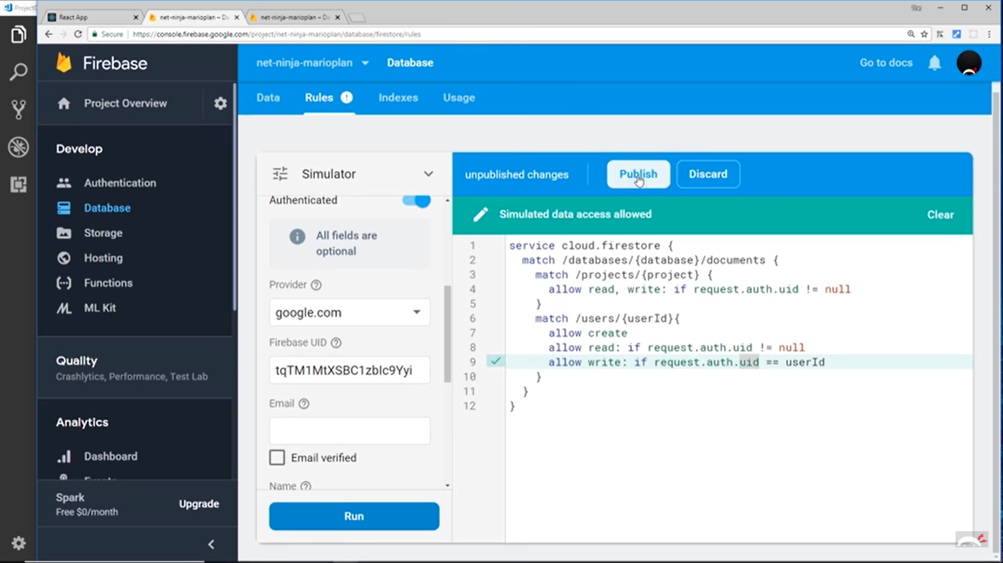

So basically the first 2 lines are untouched. Then we can use match / projects to go tot the project collection and then grab a single project using {project} and then use allow read/write : if request.auth.uid !=null ,means that the user is signed in.

Also in case of users we allow creae to everyone, then use the allow rute and read conditionally.

1. Cloud Functions :
   1. They are functions that are to be run by firebase. SO first we need to install – Go to functions in the firestore and follow the steps to deploy the code. In the directory use the spacebar to select and enter to move onto the next question
   2. Then use : Set-ExecutionPolicy -ExecutionPolicy Bypass -Scope CurrentUser

Before using *firebase init -> firebase deploy.* Then follow the steps and select the Hosting and Cloud functions only and no to EML step. Then use **dist** for the public directory and then yes.

* 1. Now for making a simple function use the following and then deploy that function only using : *firebase deploy –only functions .* This deploys the function and you get a url. This is because you wanted an http request. This basically runs on the firestore server.
  2. This will work only if you convert node:’10’ to ‘8’ in package.json in functions folder.

1. Notifications :
   1. Create the template using the card components and use the ul tag to display the list.

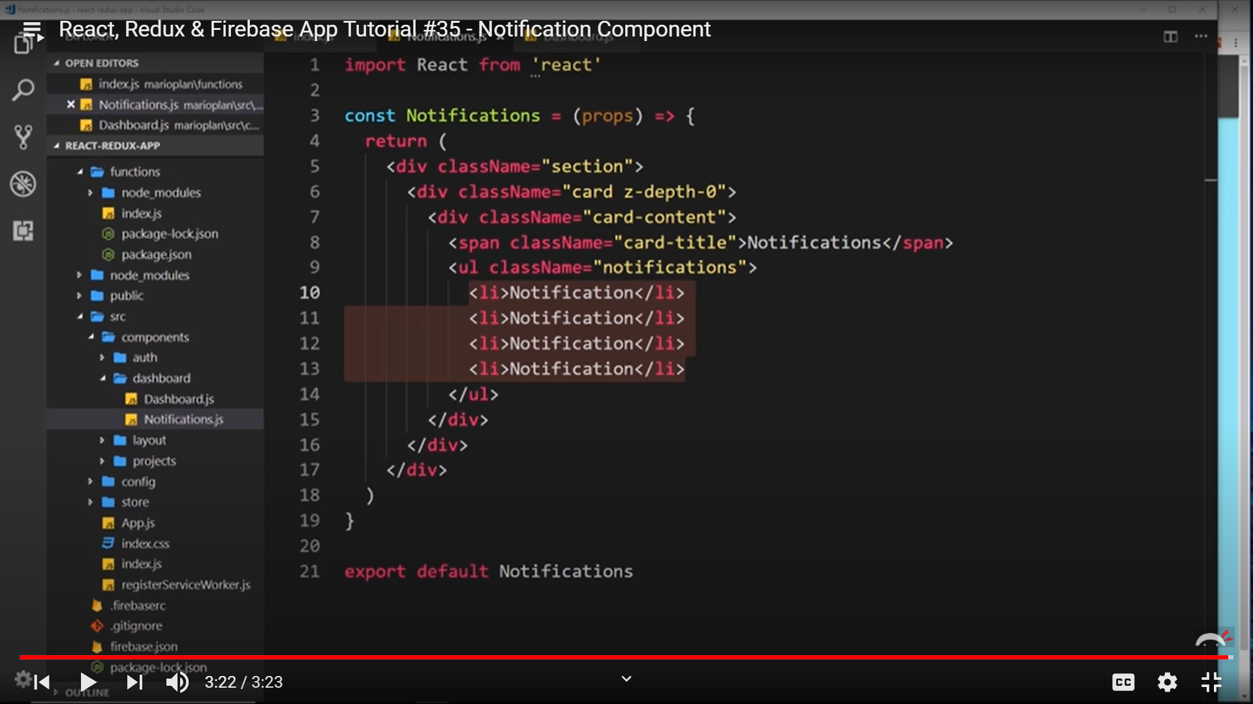

* 1. Project Trigger Function :

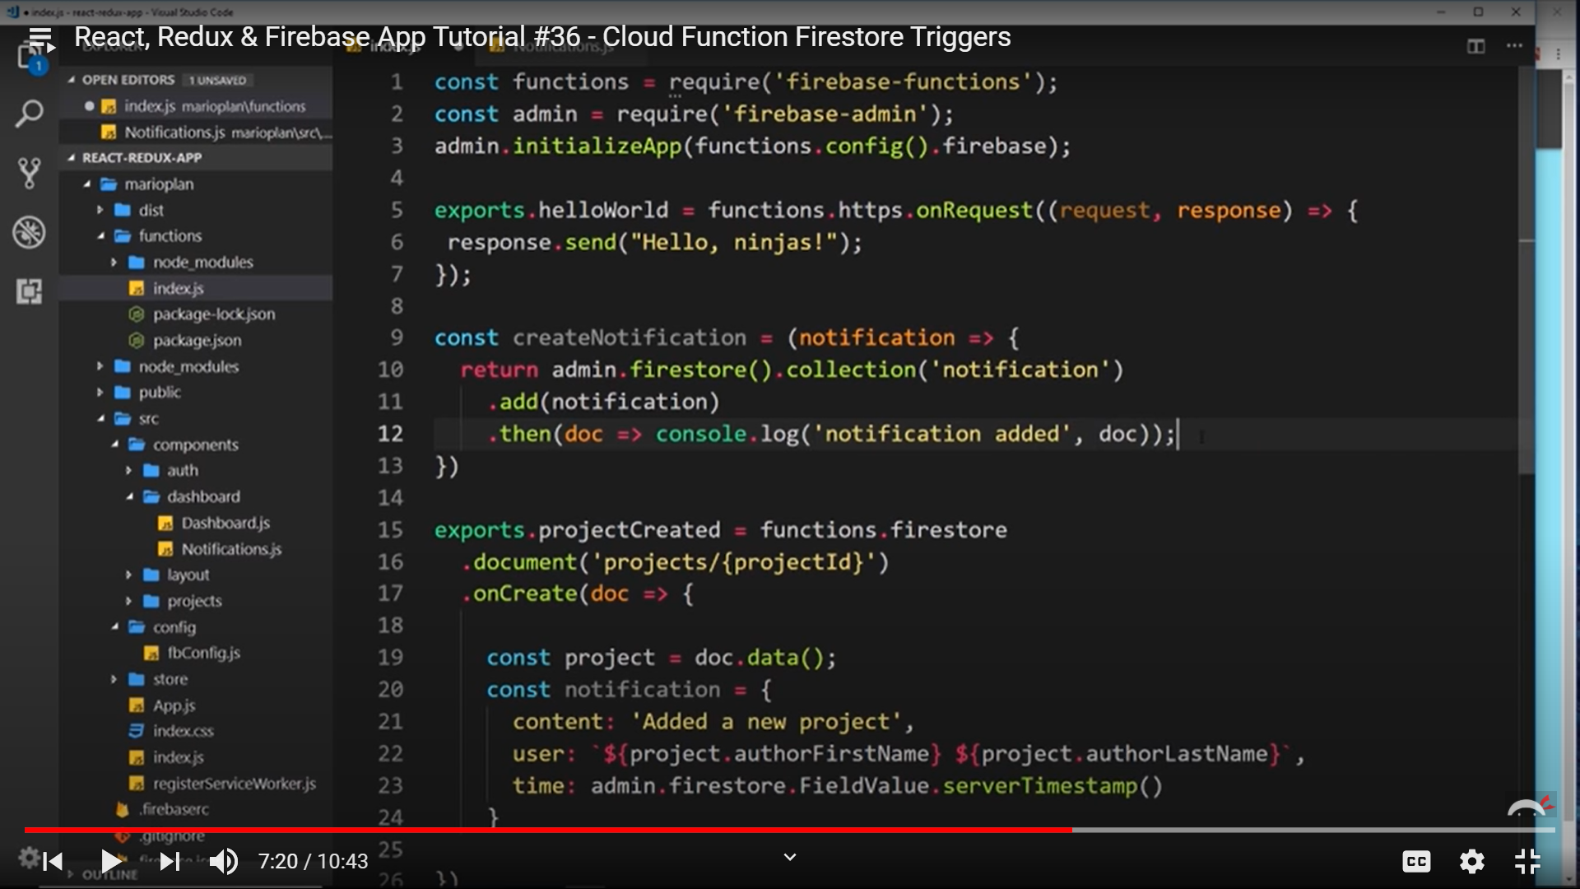

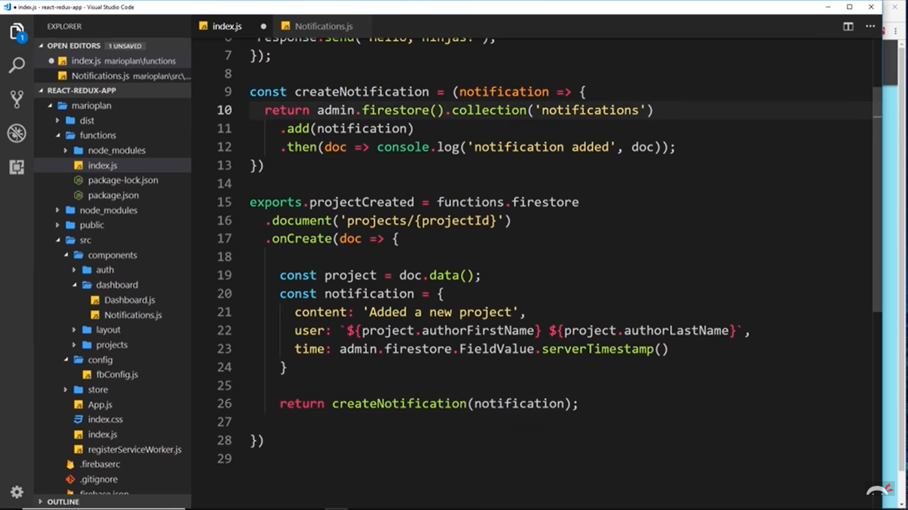

* + 1. Call the firebase admin using the first 2 statements and initializeApp in it.
    2. Then export.createdProject basically gets the details of the project that’s added to the dashboard and puts it in the notification variable.
    3. Then just use the createdNotification function to take the notification which was created and put it in the notification collections.
  1. Authentication Trigger :

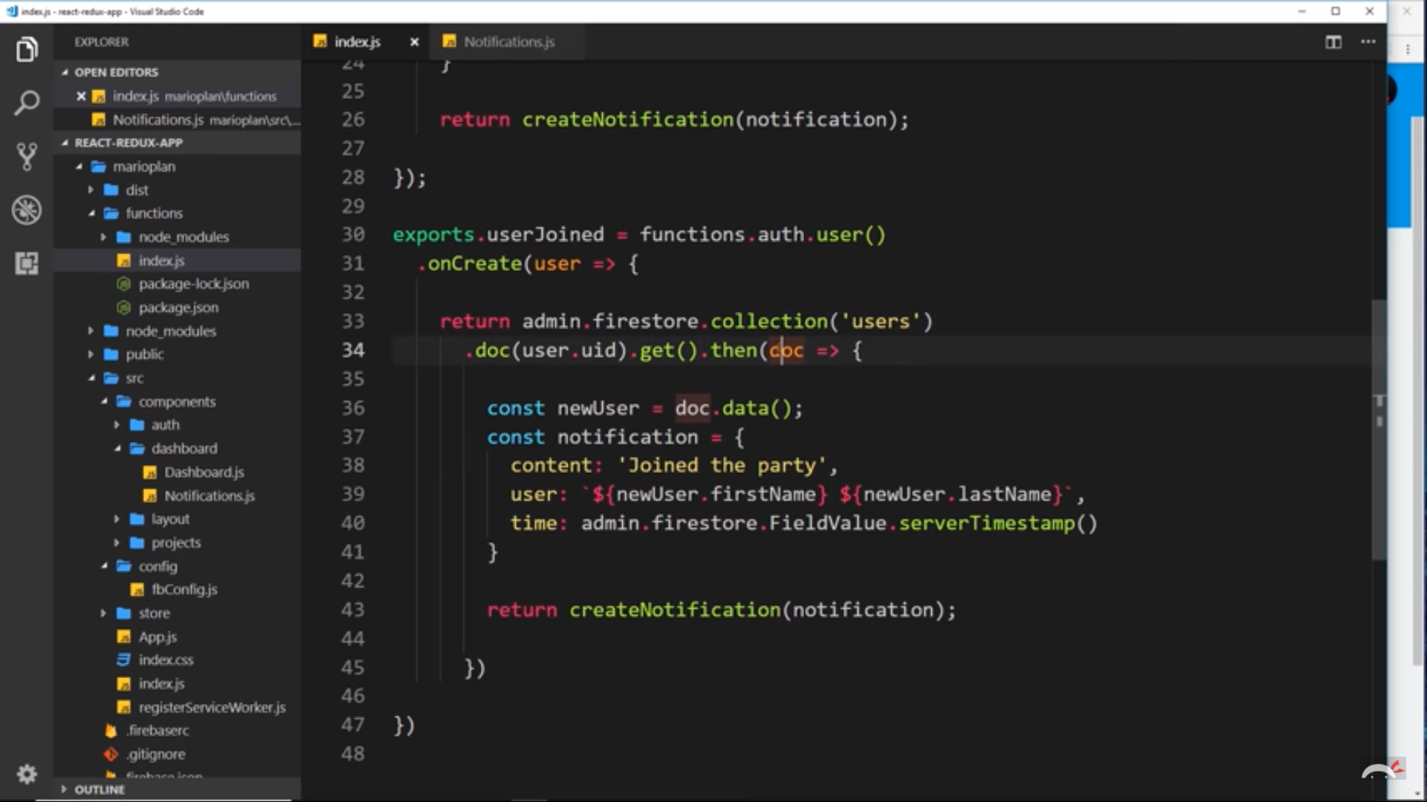

* + 1. You use the auth of the functions here and then check if a user signed up. Then take the user and return. Now here we go to the firestore collections data and we get the user do of user.uid from there and use that o create a notification which we will pass to the createNotification function to be excuted.
  1. Connecting Notifications :
     1. As we have the Dashboard connected to the Firestore we will use that to get the notification collection from the firestore and pass it to the props and then pass that as a prop to the Notification component and then map through the array and print the notifications one by one.

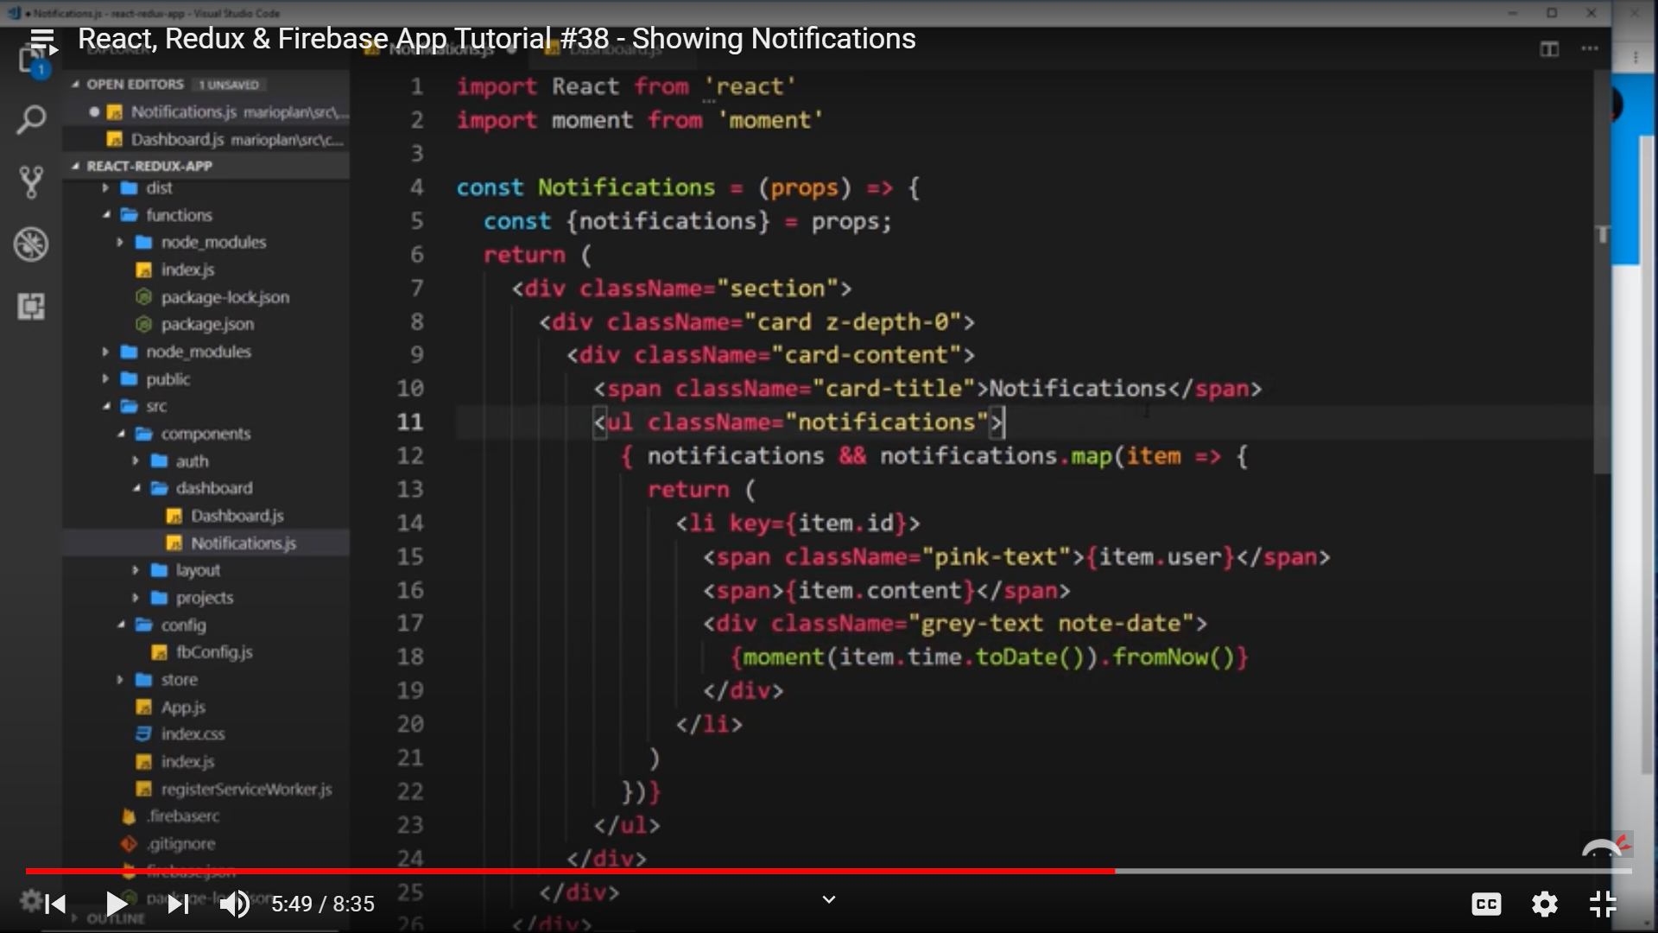

1. Ordering Data Retrieval from Firestore :
   1. All you need to di is just use the phrase **orderBy : [‘time’,’desc’]** in both the data retrievals places. The **time** in there shows we need to sort by time and **desc**  shows we need to sort in descending order.

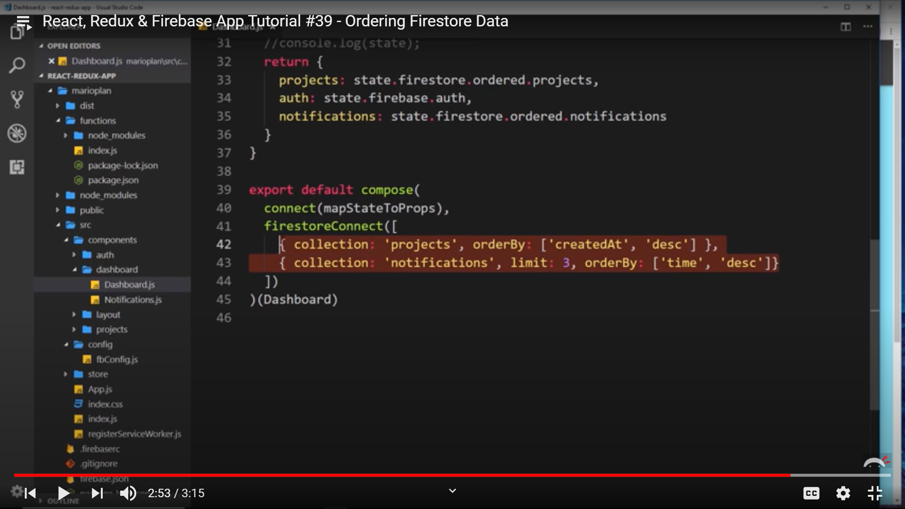

1. Hosting :
   1. Firstly use : npm run build
   2. The above statement puts our project into a build folder. Now we need to copy our files from build to dist folder as we had declared in the firebase that we have to deploy that folder.
   3. Finally use *firebase deploy*.
   4. Go to the firebase hosting and you will see the link to your project there.

Structure : Css and Components Preparation -> Connect Redux and Thunk -> Connect Firebase and Config -> Data Extraction and Updation from Firebase -> Authentication Services -> SignIn -> Sing up -> attachAuthIsReady -> Cloud Trigger(for Notifications) -> Hosting.